Name

Mathematics Stage 5 Core
Right-Angled Trigonometry

Book 1 | Further derivatives of functions  Techniques of integration | Version: 261002  Feedback:  https://MrDingMaths.com
Contents
Syllabus Content 2
Learning Intention 3

Syllabus Content
MA5-TRG-C-01 applies trigonometric ratios to solve right-angled triangle problems
Demonstrate and explain the constancy of trigonometric ratios for a given angle in a right-angled triangle
- Identify and label the hypotenuse, adjacent and opposite sides with respect to a given angle in a right-angled triangle in any orientation
- Define the sine, cosine and tangent ratios for angles in right-angled triangles and use trigonometric notation$\sin{θ},\cos{θ},\tan{θ}$
- Identify the sine, cosine and tangent ratios in a right-angled triangle
- Verify the constancy of the sine, cosine and tangent ratios for a given angle by applying knowledge of similar right-angled triangles
- Find approximations of the trigonometric ratios for a given angle
- Find the size of an angle given one of the trigonometric ratios for the angle using digital tools
Apply trigonometry to solve right-angled triangle problems
- Apply trigonometry to find the lengths of unknown sides in right-angled triangles with a given angle including angles in degrees and minutes
- Apply trigonometry to find the size of unknown angles in right-angled triangles including in degrees and minutes
- Solve a variety of practical problems involving trigonometric ratios in right-angled triangles

Sides of a Right-angled Triangle

- Sides of a Right-angled Triangle
The three sides of a right-angled triangle are named based on an angle θ:
Hypotenuse | Adjacent | Opposite
Longest side  Opposite the right-angle  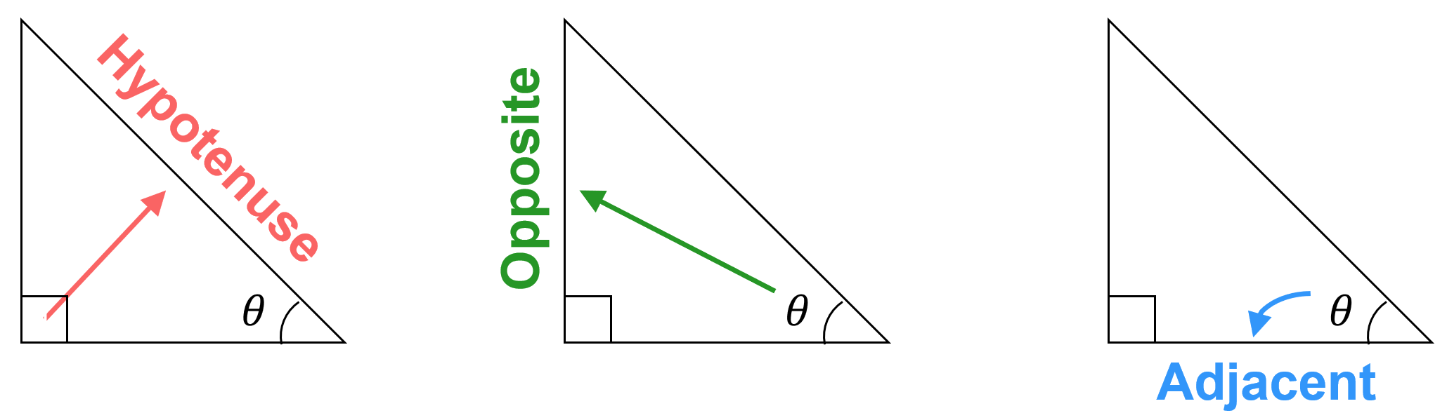 | Next to the angle,  but not the hypotenuse | Furthest side from the angle

- Identify hypotenuse, adjacent, and opposite sides
$$θ$$  $$H$$  $$O$$  $$A$$ | $$θ$$ | $$θ$$
$$θ$$ | $$θ$$ | $$θ$$
$$θ$$ | $$θ$$ | $$θ$$  There is no H, O, A for non-right-angled triangles.

Foundation
- Label the sides of these right-angled triangles.
Remember that the hypotenuse is always opposite the right-angle.
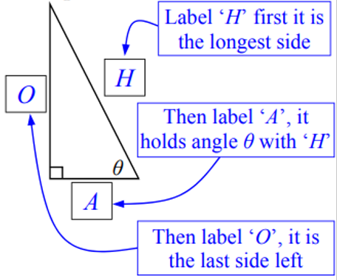 | 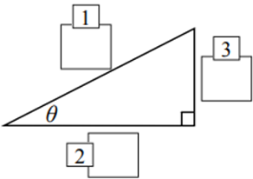  H  O  A | 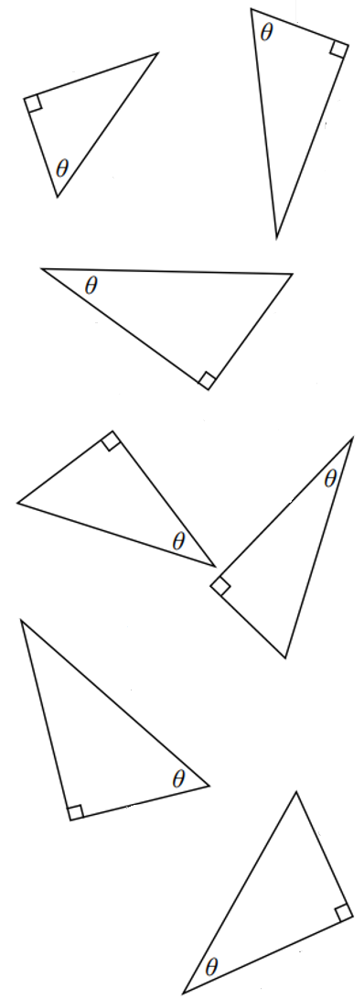  O  H  A | A  H  O
H  O  A | O  A  H | H  O  A | H  O  A
H  P  A | H  A  O | O  H  A | 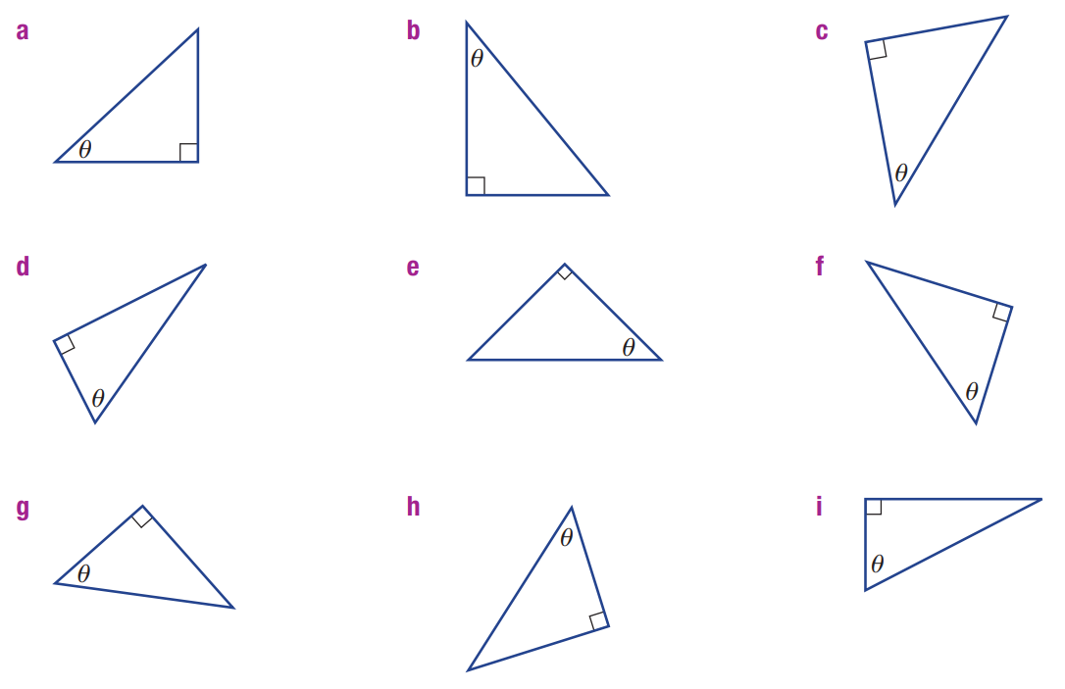  O  H  A
O  A  H | O  H  A | A  O  H | A  H  O

- Identify the hypotenuse, adjacent and opposite.
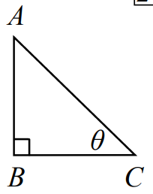  Hypotenuse: ………  AC  Adjacent: ………  BC  Opposite: ………  AB | 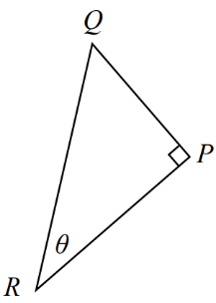  Hypotenuse: ………  QR  Adjacent: ………  RP  Opposite: ………  QP

- Label the side lengths H, A, or O
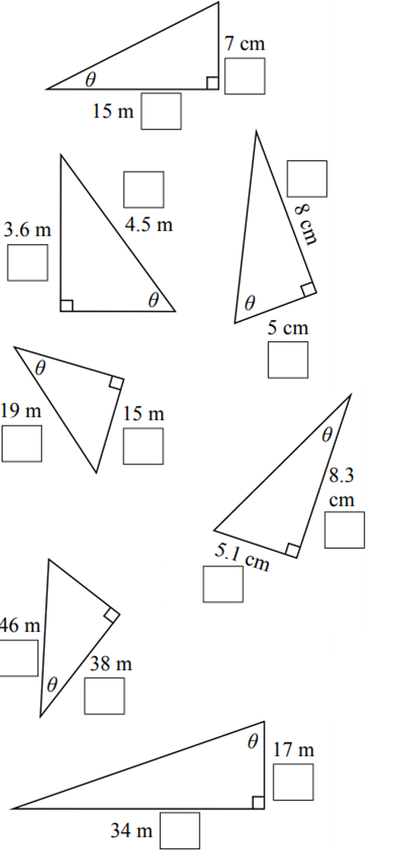  O  A | H  O | O  A | H O
A  O | 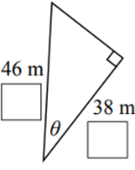  H  A | A  O | 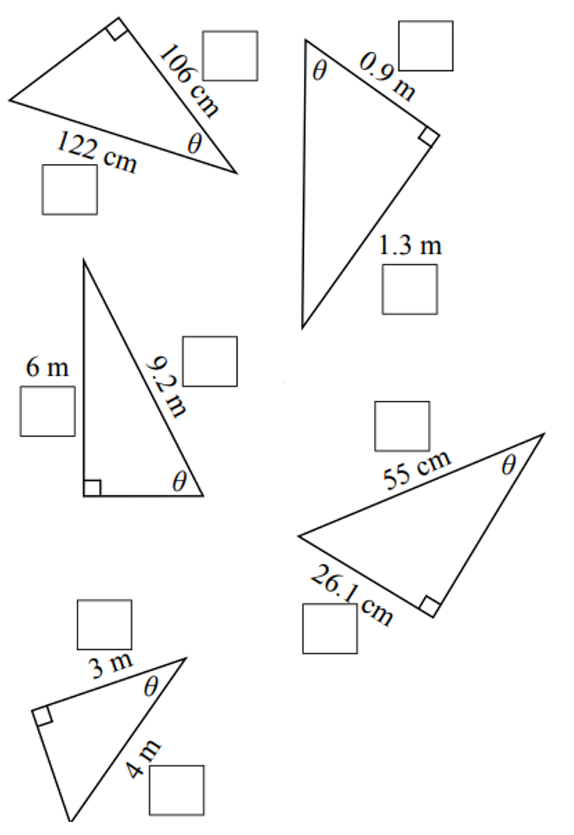  A  H
A  O | H  O | H  O | A  H
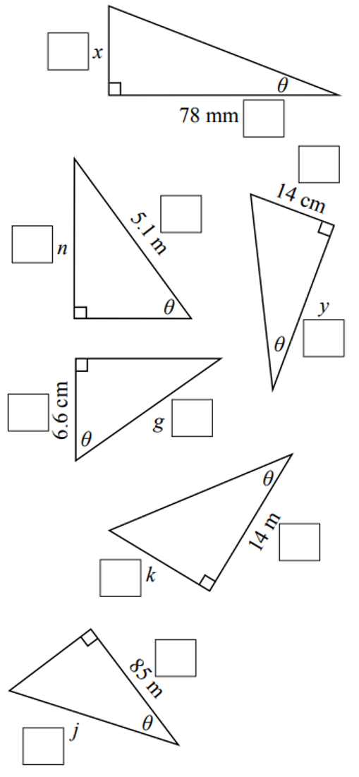  O  A | H  O | O  A | A H
A  O | A  H | 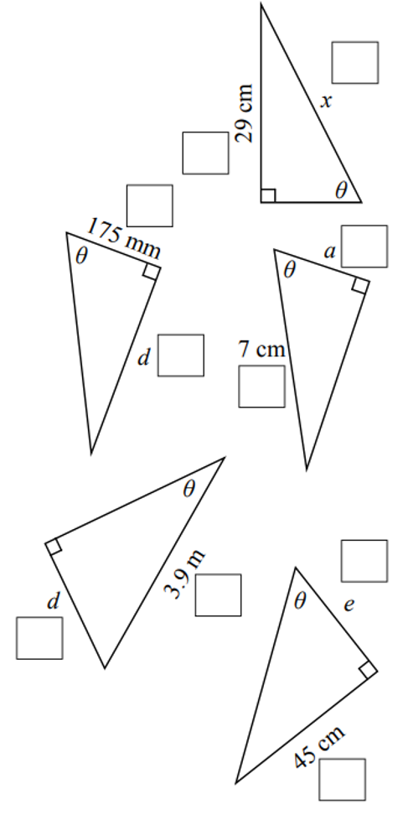  H  O | H  O

- For the triangle shown, state the length of the:
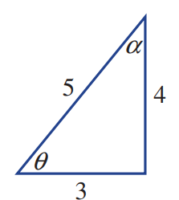
  - hypotenuse …………
5
  - side adjacent to angle θ …………
3
  - side adjacent to angle α …………
4
  - side opposite angle θ …………
4
  - side opposite angle α …………
3

The Trigonometric Ratios

- The Trigonometric Ratios
- There are three trigonometric ratios: sine, cosine, and tangent, which compare the lengths of two sides of a triangle.
- The ratios specify an angle, as the opposite and adjacent sides depend on the angle.
- You can remember the three ratios using SOH CAH TOA
$$\sin{θ}=\frac{Opposite }{Hypotenuse}$$ | $$\cos{θ}=\frac{Adjacent }{Hypotenuse}$$ | $$\tan{θ}=\frac{Opposite}{Adjacent}$$
- Identify the sides of the right-angled triangle: H, A, O
- Write the trig ratios.

- Example Identify sine, cosine, and tangent ratios
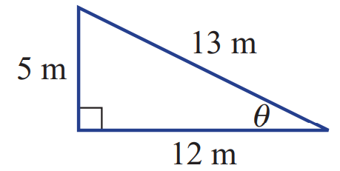  $$H$$  $$O$$  $$A$$ | $$\sin{θ}=\frac{Opp}{Hyp}=\frac{5}{13}$$  $$\cos{θ}=\frac{Adj}{Hyp}=\frac{12}{13}$$  $$\tan{θ}=\frac{Opp}{Adj}=\frac{5}{12}$$

- Guided Practice
Identify the sine, cosine, and tangent ratios of the below triangles
$$\sin{θ}=\frac{Opp}{Hyp}=$$  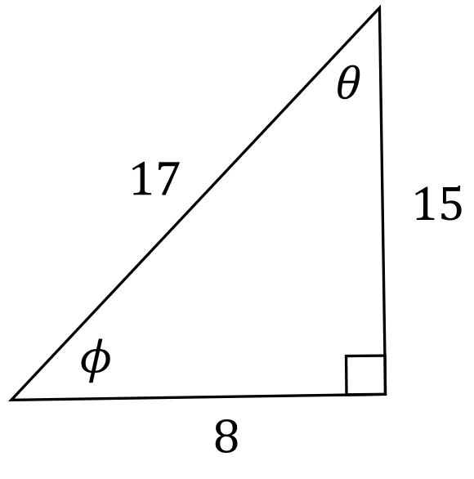  $\frac{8}{17}$  $$\cos{θ}=\frac{Adj}{Hyp}=$$  $$\frac{15}{17}$$  $$\tan{θ}=\frac{Opp}{Adj}=$$  $$\frac{8}{15}$$ | $$\sin{ϕ}=\frac{Opp}{Hyp}=$$  $\frac{15}{17}$  $$\cos{ϕ}=\frac{Adj}{Hyp}=$$  $$\frac{8}{17}$$  $$\tan{ϕ}=\frac{Opp}{Adj}=$$  $$\frac{15}{8}$$

- Key Ideas
- The trigonometric ratios compare lengths of two ……………… of a right-angled triangle.
- The sine ratio compares the ……………… and ………………
- The cosine ratio compares the ……………… and ………………
- The tangent ratio compares the ………………… and ………………
- The trigonometric ratios must specify an …………………, as the opposite and adjacent sides depend on the angle.

Foundation
- Label the sides, then write the ratios $\sin{θ},\cos{θ},\tan{θ}$
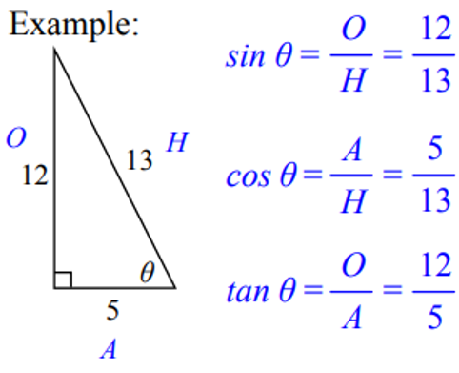 | 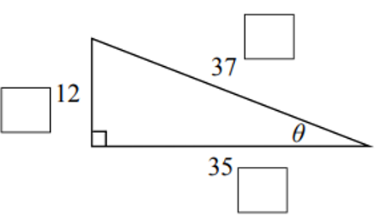  $$\sin{θ=\frac{12}{37}}, \cos{θ}=\frac{35}{37}, \tan{θ}=\frac{12}{35}$$ | 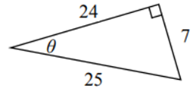  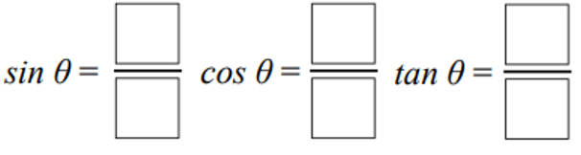  $$\sin{θ=\frac{7}{25}}, \cos{θ}=\frac{24}{25}, \tan{θ}=\frac{7}{24}$$
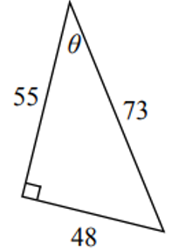  $$\sin{θ=\frac{48}{73}}, \cos{θ}=\frac{55}{73}, \tan{θ}=\frac{48}{55}$$ | 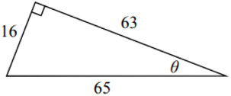  $$\sin{θ=\frac{16}{65}}, \cos{θ}=\frac{63}{65}, \tan{θ}=\frac{16}{63}$$ | 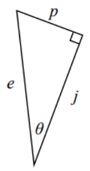  $$\sin{θ=\frac{p}{e}}, \cos{θ}=\frac{j}{e}, \tan{θ}=\frac{p}{j}$$
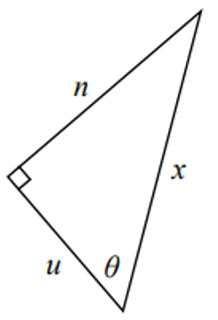  $$\sin{θ=\frac{n}{x}}, \cos{θ}=\frac{u}{x}, \tan{θ}=\frac{n}{u}$$ | 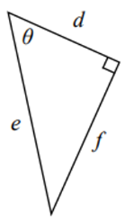  $$\sin{θ=\frac{f}{e}}, \cos{θ}=\frac{d}{e}, \tan{θ}=\frac{f}{d}$$ | 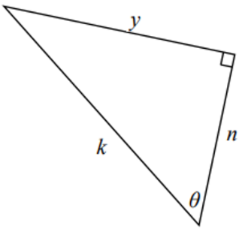  $$\sin{θ=\frac{y}{k}}, \cos{θ}=\frac{n}{k}, \tan{θ}=\frac{y}{n}$$

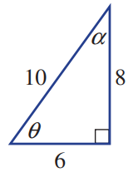
- For the triangle shown, write the trigonometric ratio for:
- $\sin{θ}=$  $$\frac{8}{10}=\frac{4}{5}$$ | - $\cos{θ}=$  $$\frac{6}{10}=\frac{3}{5}$$ | - $\tan{θ}=$  $$\frac{8}{6}=\frac{4}{3}$$
- $\sin{α}=$  $$\frac{6}{10}=\frac{3}{5}$$ | - $\cos{α}=$  $$\frac{8}{10}=\frac{4}{5}$$ | - $\tan{α}=$  $$\frac{6}{8}=\frac{3}{4}$$

Development
- Label the given sides then decide the appropriate ratio that relates the two sides.
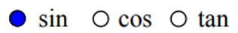  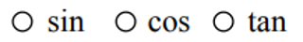 | tan | 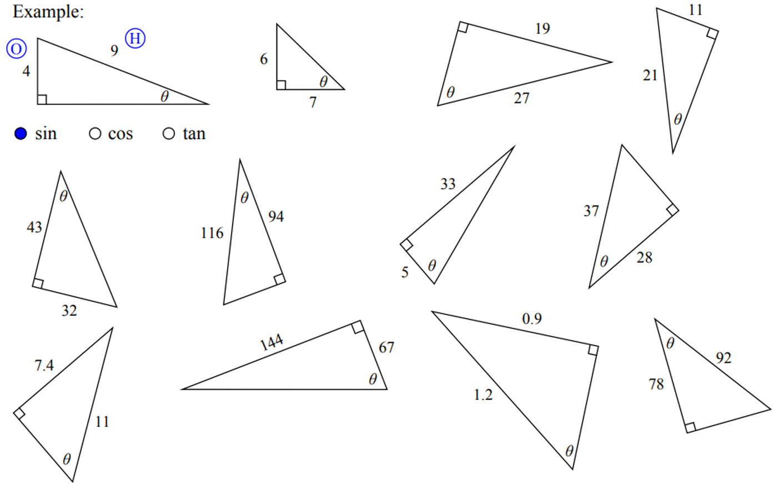  sin | sin
tan | cos | tan | sin
tan | sin | cos | 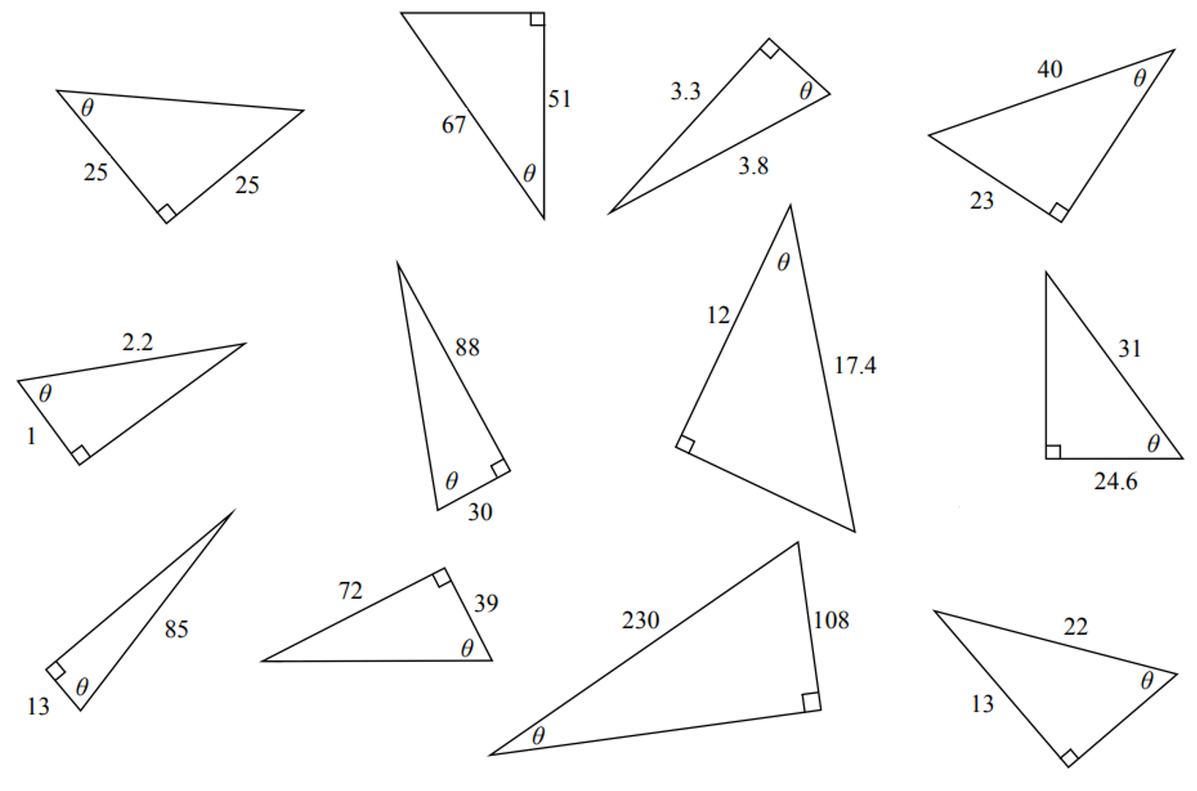  tan
cos | sin | cos | tan
cos | tan | sin | 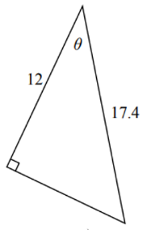  cos

- Use the given sides to write a trigonometric ratio for each triangle.
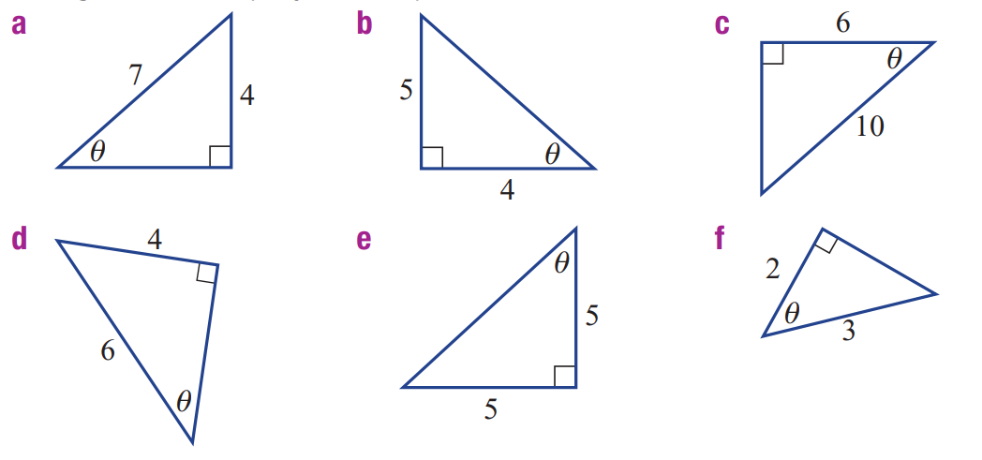  Given sides: O, H  Appropriate ratio: sine  $$\sin{θ}=\frac{4}{7}$$ | Given sides: …… , ……  Appropriate ratio: …………  …… $θ=$ …………  $$\tan{θ}=\frac{5}{4}$$ | Given sides: …… , ……  Appropriate ratio: …………  ……………………  $$\cos{θ}=\frac{6}{10}=\frac{3}{5}$$
$$\sin{θ}=\frac{4}{6}=\frac{2}{3}$$ | $$\tan{θ}=\frac{5}{5}=1$$ | $$\cos{θ}=\frac{2}{3}$$
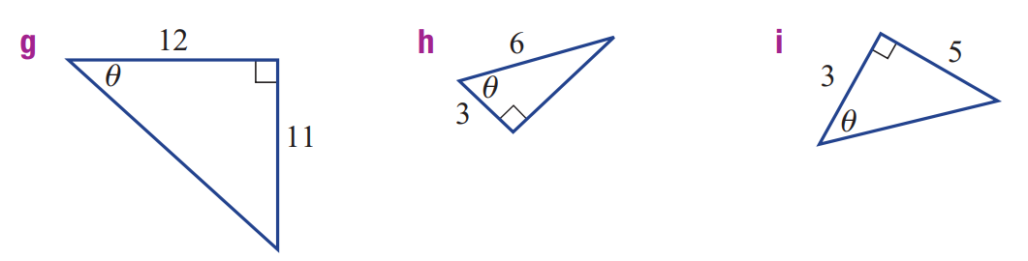  $$\tan{θ}=\frac{11}{12}$$ | $$\cos{θ}=\frac{3}{6}=\frac{1}{2}$$ | $$\tan{θ}=\frac{5}{3}$$

- Use Pythagoras’ Theorem to find the unknown side and then find the ratios for $\sin{θ},\cos{θ},$and $\tan{θ}$.
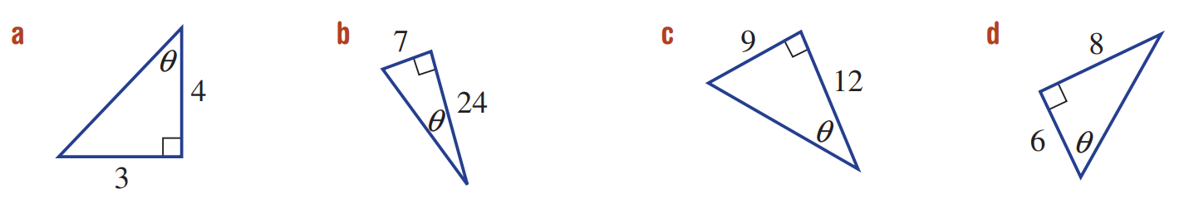  $$\sin{θ=\frac{3}{5}}, \cos{θ}=\frac{4}{5}, \tan{θ}=\frac{3}{4}$$ | $$\sin{θ=\frac{7}{25}}, \cos{θ}=\frac{24}{25}, \tan{θ}=\frac{7}{24}$$
$$\sin{θ=\frac{9}{15}=\frac{3}{5}}, \cos{θ}=\frac{12}{15}=\frac{4}{5}, \tan{θ}=\frac{9}{12}=\frac{3}{4}$$ | $$\sin{θ=\frac{8}{10}=\frac{4}{5}}, \cos{θ}=\frac{6}{10}=\frac{3}{5}, \tan{θ}=\frac{8}{6}=\frac{4}{3}$$

Constancy of the Trigonometric Ratios

- Constancy of the trigonometric ratios
- Trigonometric Ratios: https://www.geogebra.org/m/k8qwer8j
For a triangle with a $30°$ interior angle, what is the ratio of:
$\sin{30°}=$ $\frac{Opposite}{Hypotenuse}$ | $\cos{30°}=$ $\frac{Adjacent}{Hypotenuse}$ | $\tan{30°}=$ $\frac{Opposite}{Adjacent}$
Do these values change if you make the triangle larger or smaller?

Type $\sin{30°}$, $\cos{30°}$, and $\tan{30°}$ into your calculator.
$\sin{30°}=$ | $$\cos{30°}=$$ | $$\tan{30°}=$$
What do you notice?

Complete the sentence:
The trigonometric ratios are always ………………… for a given angle, no matter the size of the triangle.

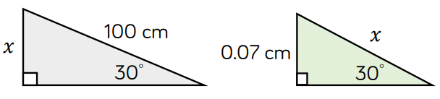
Hence, find $x$ for these triangles:
…………… ……………

Now we’ll change the angle of the triangle. What changes, and what stays the same?

- Key Ideas
- The …………………… ratios remain ………………… for a given angle.

Foundation
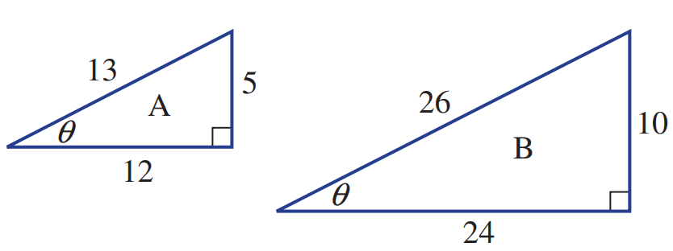
- Here are two similar triangles A and B

  - Explain what is meant when two figures are similar.
All angles equal.
Corresponding sides are in the same ratio.
- Write the ratio $\sin{θ}$for triangle A.  $$\sin{θ}=\frac{5}{13}$$ | - Write the ratio $\sin{θ}$for triangle B.  $$\sin{θ}=\frac{10}{26}=\frac{5}{13}$$
- Write the ratio $\cos{θ}$ for triangle A.  $$\cos{θ}=\frac{12}{13}$$ | - Write the ratio $\cos{θ}$ for triangle B.  $$\cos{θ}=\frac{24}{26}=\frac{12}{13}$$
- Write the ratio $\tan{θ}$ for triangle A.  $$\tan{θ}=\frac{5}{12}$$ | - Write the ratio $\tan{θ}$ for triangle B.  $$\tan{θ}=\frac{10}{26}=\frac{5}{12}$$
  - What do you notice about your answers? (hint: fully simplify them).
The trigonometric ratios are the same for similar triangles.
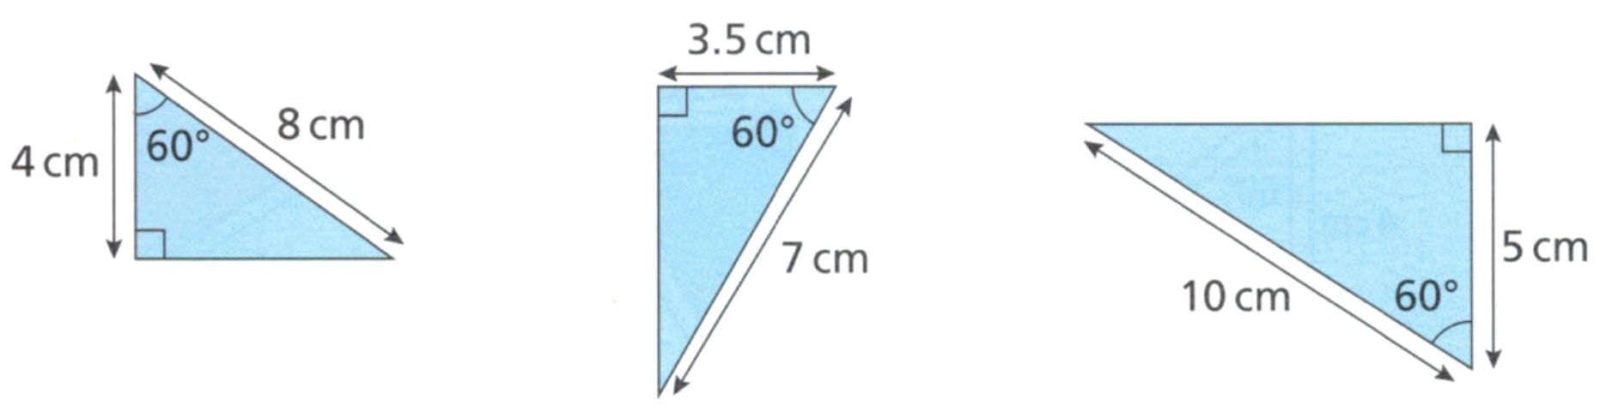
- Consider these triangles.

  - Explain why these three triangles are similar.
They have the same angles: 90$°$, 60$°$, and 30$°$ (using angle sum of a triangle)
  - Calculate the ratio of $\frac{Adjacent}{Hypotenuse}$ for each of the triangles.
$$\frac{4}{8}=\frac{1}{2}, \frac{3.5}{7}=\frac{1}{2}, \frac{5}{10}=\frac{1}{2}$$
  - What do you notice?
Cos ratio for all three triangles are equal.
  - Type $\cos{60}°$ in your calculator. What does this tell you about $\frac{Adjacent}{Hypotenuse}$ for any right-triangle with $60°$?
$\cos{60}=$ $\frac{1}{2}$ for any right-angled triangle.

Development
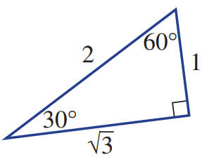
- For the triangle shown, write the trigonometric ratio for:
- $\sin{30°}=$  $$\frac{1}{2}$$ | - $\cos{30°}=$  $$\frac{\sqrt{3}}{2}$$ | - $\tan{30°}=$  $$\frac{1}{\sqrt{3}}$$
- $\sin{60°}=$  $$\frac{\sqrt{3}}{2}$$ | - $\cos{60°}=$  $$\frac{1}{2}$$ | - $\tan{60°}=$  $$\sqrt{3}$$

What do you notice about cos 30° and sin 60°?
They’re equal.
What do you notice about cos 60° and sin 30°?
They’re equal.
- Use the fact that $\cos{60°=\frac{1}{2}}$ to find the value of $x$ in each of these triangles.
$x=6$ cm | 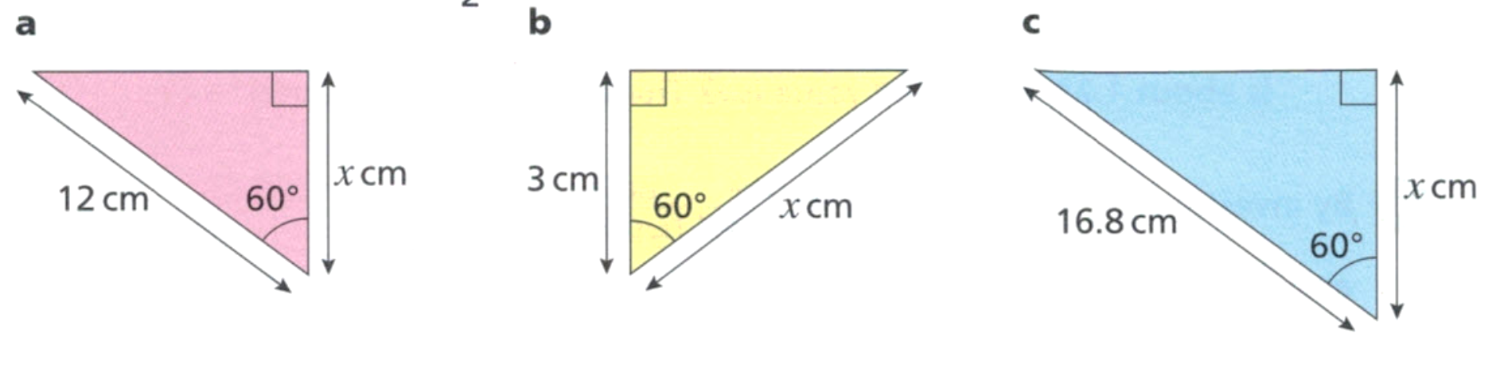  $x=6$ cm | $x=8.4$ cm

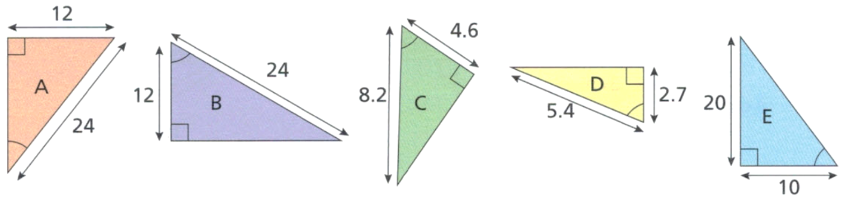
- Use the fact that $\cos{60°=\frac{1}{2}}$ to determine in which of these triangles the angle is 60°.

Triangle B and D.

Mastery
- A right-angled triangle has cosine ratio of $\frac{1}{2}$. Every side of the triangle is made 3 times longer. What is the new cosine ratio? Explain your answer using a diagram if necessary.

It is still $\frac{1}{2}$, as the triangles are similar, the ratios are equal.
- A right-angled triangle has an interior angle of $45°$. Is it always isosceles?
Explain by using the tangent ratio.
$$\tan{45°}=\frac{O}{A}=1$$
Since $\frac{O}{A}$ $=1$, $O=A$
Two sides of a triangle are equal, so it is isosceles.
- Explain why it is impossible to have a right-angled triangle with these properties.
- $\tan{θ}=-1$  $\frac{O}{A}$ $=-1$, this implies either O or A is negative,  but a length can’t be negative. | - $\sin{θ}=1$  $\frac{O}{H}$ $=1$, so $O=H$,  impossible the hypotenuse is always the longest side.
- $\cos{θ}=0$  $\frac{A}{H}$ $=0$, so $A=0$,  but length can’t be zero. | - $\sin{θ}>1$ or $\cos{θ}>1$  $$\frac{O}{H}>1, O>H or$$  $$\frac{A}{H}>1, A>H$$  Impossible as hypotenuse is always the longest side.

- For the triangle shown,
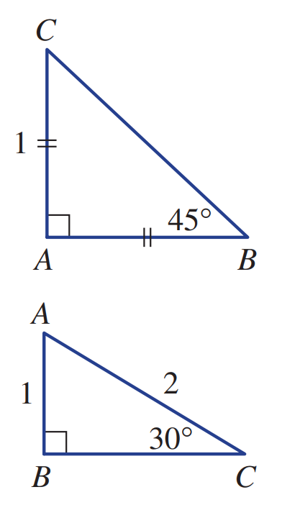
  - use Pythagoras’ theorem to find the exact length BC.

$$\sqrt{2}$$
  - use your result from part a to write down the exact values of:
- $\sin{45°}$  $$\frac{1}{\sqrt{2}}$$ | - $\cos{45°}$  $$\frac{1}{\sqrt{2}}$$ | - $\tan{45°}$  $$1$$

- For the triangle shown,
  - use Pythagoras’ theorem to find the exact length BC.

$$\sqrt{3}$$
  - use your result from part a to write down the exact values of:
- $\sin{30°}$  $$\frac{1}{2}$$ | - $\cos{30°}$  $$\frac{\sqrt{3}}{2}$$ | - $\tan{30°}$  $$\frac{1}{\sqrt{3}}$$
- $\sin{60°}$  $$\frac{\sqrt{3}}{2}$$ | - $\cos{60°}$  $$\frac{1}{2}$$ | - $\tan{60°}$  $$\sqrt{3}$$

- Evaluate $\frac{\sin{20°}}{\cos{20°}}$. How does this compare to $\tan{20°}$?

They are equal.
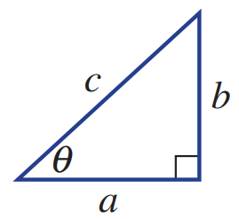
For this triangle with side lengths a, b and c , find an expression for:
- $\sin{θ}$  $$\frac{b}{c}$$ | - $\cos{θ}$  $$\frac{a}{c}$$ | - $\tan{θ}$  $$\frac{b}{a}$$ | - $\frac{\sin{θ}}{\cos{θ }}$  $$\frac{\left(\frac{b}{c}\right)}{\left(\frac{a}{c}\right)}$$  $$=\frac{b}{c}÷\frac{a}{c}$$  $$=\frac{b}{c}×\frac{c}{a}$$  $$=\frac{b}{a}$$

Evaluating a Trigonometric Ratio

- Trigonometric Ratios are Stored in your Calculator
- Trigonometric ratios for a given angle are constant in all right-angled triangles.
- Calculators store these ratios.
- Knowing an angle lets you find the ratio between two sides.

- Calculate the value of a trigonometric ratio
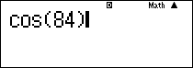  $\cos{84°}$  $≈0.1045$ |  | 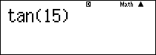  $\tan{15°}$  $≈0.2679$
What does $\cos{84°}$ mean?
Answer using these words: right-angled triangle, adjacent, hypotenuse, ratio.
$\cos{84°}$ refers to the ………… of ………………… divided by ………………… in a ……………-…………… ………………… with an angle of …………
Evaluate the following to 4 decimal places.
- $\sin{12°}$  0.2079 | - $\cos{12°}$  0.9781 |  | - $\tan{42°}$  0.9004
- $7cos{29°}$  6.1223 | - $3\tan{56°}$  4.4477 |  | - $14\cos{12°}$  13.6941
- $12 sin{19.3°}$  3.9662 | - $\frac{\tan{56°}}{3}$  0.4942 |  | - $\frac{4\cos{16°}}{5}$  0.7690

Foundation
- Use a calculator to evaluate the following correct to 4 decimal places.
- $\sin{20°}=$  0.3420 | - $\cos{37°}=$  0.7986 | - $\tan{64°}=$  2.0503
- $\sin{47°}=$  0.7314 | - $\cos{84°}=$  0.1045 | - $\tan{14°}=$  0.2493
- $\cos{13°}=$  0.9744 | - $\tan{47°}=$  1.0724 | - $\sin{36°}=$  0.5878
- $12\sin{13°}=$  2.6994 | - $6 tan{82.3°}=$  44.3770 | - $9\sin{31.3°}=$  4.6757
- $13.\sin{31°}=$  6.6955 | - $150 cos{18.5°}=$  142.2485 | - $0.5\tan{51.63°}=$  0.6315
- $\frac{9}{\sin{57°}}$ $=$  10.7313 | - $\frac{28}{\cos{74°}}$ $=$  101.5827 | - $\frac{53.2}{\tan{42°}}$ $=$  59.0846
- $\frac{4.2}{\tan{31°}}$ $=$  6.9900 | - $\frac{0.64}{\sin{18.2°}}$ $=$  2.0491 | - $\frac{291}{\cos{3.45°}}$ $=$  291.5283

Finding the Value of an Angle

- Finding the Value of an Angle
- Given an angle, you can use trigonometry to find the ratio of two sides of a triangle.
- The reverse is also true: given a trigonometric ratio, you can find the angle.
- To do so, use the inverse trigonometric function:
Inverse Sine | Inverse Cosine | Inverse Tangent
$$\sin{θ}=\frac{O}{H} \\ θ=\sin^{-1}\left(\frac{O}{H}\right)$$ | $$\cos{θ}=\frac{A}{H} \\ θ=\cos^{-1}\left(\frac{A}{H}\right)$$ | $$\tan{θ}=\frac{O}{A} \\ θ=\tan^{-1}\left(\frac{O}{A}\right)$$
$\sin^{-1}{(0.4369)}$ is read “sine inverse 0.4369” and means “the angle with a sine ratio of 0.4369”

- Find the value of an angle
$\sin{θ=0.6314}$    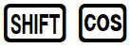  $θ=\sin^{-1}\left(0.6314\right)$  $≈39°$ |  | $\cos{θ}=\frac{8}{10}$  $θ=\cos^{-1}\left(\frac{8}{10}\right)$  $≈37°$
What does $\sin^{-1}{(0.6314)}$ mean?
Answer using these words: right-angled triangle, opposite, hypotenuse, ratio, angle, inverse
$\sin^{-1}{(0.6314)}$, which is read as “sine …………… 0.6314”, is used to find the ……………… in a …………-…………… ……………… where the ……………… of ………………… to ………………… is 0.6314.
How do you know when to apply the inverse trigonometric ratio?
We apply the inverse trigonometric ratio when trying to find an ……………………
How do you input $\sin^{-1}{(0.6314)}$ in a calculator?
First press the ………… button, then press the …………… button.
Calculate the value of $θ$ in these equations. Round your answer to 4 decimal places.
- $\sin{θ=0.4371}$  $θ=\sin^{-1}{( )}$  $≈$  25.9190° | - $\cos{θ}=0.1445$  $θ=\cos^{-1}{( )}$  $≈$  81.6917° |  | - $\tan{θ}=\frac{5}{4}$  $θ=$  $≈$  51.3402°
- $\cos{θ}=\frac{7}{12}$  54.3147° | - $\tan{θ}=1$  45° |  | - $\sin{θ}=\frac{1}{2}$  30°

Foundation
- Use a calculator to solve for $θ$. Answer to the nearest whole.
- $\sin{θ}=$ $0.5$  $θ=\sin^{-1}{(0.5)}$  $θ=$ ………  30° | - $\cos{θ}=0.5$  $θ=\cos^{-1}{( )}$  $θ=$ ………  60° | - $\tan{θ}=1$  $θ=$ ……………  $θ=$ ………  45°
- $\cos{θ}=0.8660$  30° | - $\sin{θ}=0.7071$  45° | - $\tan{θ}=0.5774$  30°
- $\sin{θ}=1$  90° | - $\tan{θ}=1.192$  50° | - $\cos{θ}=0$  90°

- Use a calculator to solve for $θ$. Answer to 4 decimal places.
- $\sin{θ}=$ $\frac{4}{7}$  $θ=\sin^{-1}\left(\frac{4}{7}\right)$  $θ=$ ………  34.8499° | - $\cos{θ}=$ $\frac{1}{4}$  75.5225° | - $\tan{θ}=$ $\frac{3}{5}$  30.9638°
- $\cos{θ}=$ $\frac{4}{5}$  36.8699° | - $\sin{θ}=$ $\frac{1}{3}$  19.4712°° | - $\tan{θ}=$ $\frac{8}{5}$  57.9946
- $\tan{θ}=$ $\frac{7}{3}$  66.8014° | - $\cos{θ}=$ $\frac{9}{13}$  46.1869° | - $\sin{θ}=$ $\frac{15}{42}$  20.9248°

Finding Unknown Sides Part 1

- Review
- Write the three trigonometric ratios, $\sin{θ}=$ $\frac{O}{H}$, $\cos{θ}=$ $\frac{A}{H}$ $\tan{θ}=$ $\frac{O}{A}$
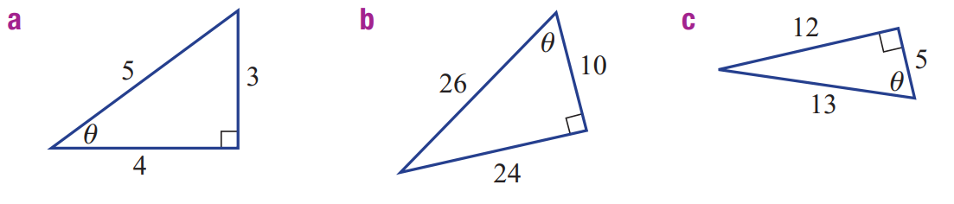

- Solve these equations.
- $\frac{x}{6}$ $=7$ | - $\frac{x}{4}$ $=5$ | - $\frac{x}{7}$ $=24$

- Match the expressions to their value.
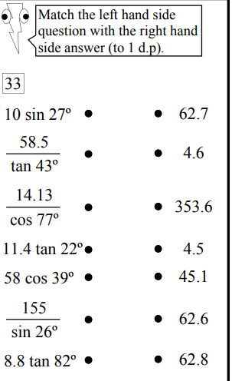

- Trigonometric Equations
- A trigonometric ratio is a number.
- Solve trigonometric equations by treating ratios as numbers.
$$\sin{30°}=\frac{x}{7} is the same as 0.5=\frac{x}{7}$$

- Example Solve trigonometric equations: unknown in numerator
$$\cos{60°}=\frac{x}{5} \\ ×5=×5 \\ 5cos{60°}=x \\ 2.5=x$$

- Guided Practice
Solve these equations. Round your answer to 2 decimal places.
$$\cos{24°=}\frac{x}{10}$$  $$x=9.14$$ | $$\sin{29°}=\frac{x}{7}$$  $$x=3.39$$
$$\tan{38°}=\frac{x}{13}$$  $$x=10.16$$ | $$\sin{23°}=\frac{x}{0.7}$$  $$x=0.27$$

- Solving for an Unknown Side
- Label the side you want to find and given side of the right-angled triangle.
- Determine the trigonometric ratio that relates these sides.
- Write the trigonometric equation.
- Substitute known values into the equation.
- Solve the equation.

- Example Calculate an unknown side using trigonometry; unknown in numerator
Calculate the value of $x$ in these right-angled triangles.
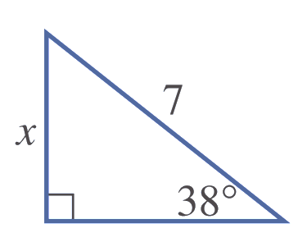  1. Label  Opp  Hyp  2. $sin$  3. $\sin{θ}=$ $\frac{O}{H}$  4. $\sin{38°}=$ $\frac{x}{7}$  5. $7\sin{38°}=x$  $x≈4.31$ | 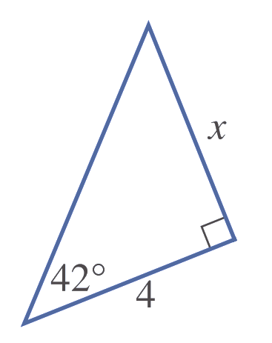  1. Label  Opp  Adj  2. tan  3. $\tan{θ=}$ $\frac{O}{A}$  4. $\tan{42°=}$ $\frac{x}{4}$  5. $4\tan{42°=x}$  $x≈3.60$

- Guided Practice
Calculate the value of $x$ in these right-angled triangles. Round your answer to 2 d.p.
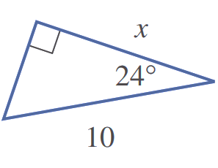  1. Label  2.  3.  4.  5.  $$x=9.14$$ | 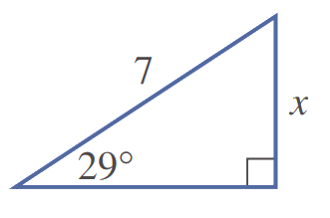  1. Label  2.  3.  4.  5.  $$x=3.39$$

Foundation
- Solve these equations to find the value of $x$ correct to 2 decimal places.
- $\sin{50°}=$ $\frac{x}{4}$  $4×\sin{50°}=x$  ………… $=x$  $$3.06$$ | - $\tan{81°}=$ $\frac{x}{3}$  … $×\tan{81°}=x$  ………… $=x$  $$18.94$$ | - $\cos{33}=$ $\frac{x}{6}$  … $×$ …… $=$ ……  …………………………………  $$5.03$$
- $\cos{75°}=$ $\frac{x}{3.5}$  $$0.91$$ | - $\sin{24°}=$ $\frac{x}{4.2}$  $$1.71$$ | - $\tan{42}=$ $\frac{x}{10}$  $$9.00$$
- $\frac{x}{7.1}$ $=\tan{18.4°}$  $$2.36$$ | - $\frac{x}{5.3}$ $=\sin{64.7°}$  $$4.79$$ | - $\frac{x}{12.6}$ $=\cos{52.9°}$  $$7.60$$
- Determine the two sides given (O, A or H), and hence which trigonometric ratio (sin, cos, or tan) should be used to solve for $x$.
tan | sin | 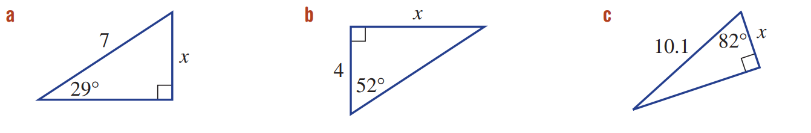  cos
- Find the side length by setting out your working as shown. Round your answer to 1 d.p.
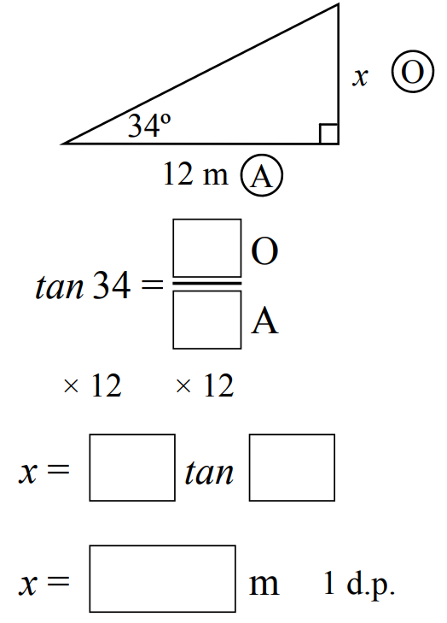  8.1 m | 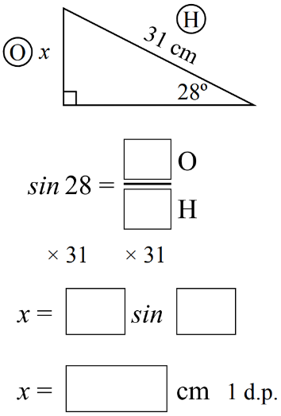  14.6 m | 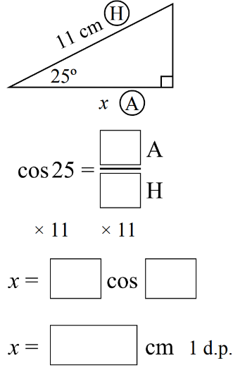  10.0 m
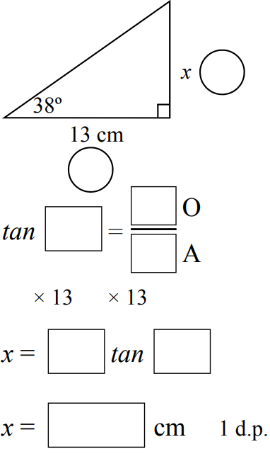  10.2 cm | 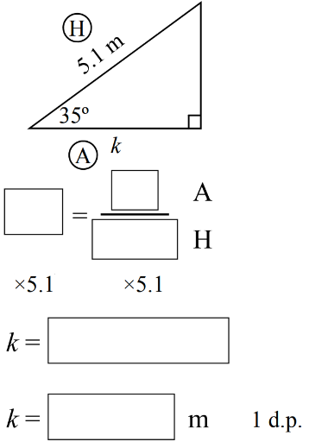  4.4 m | 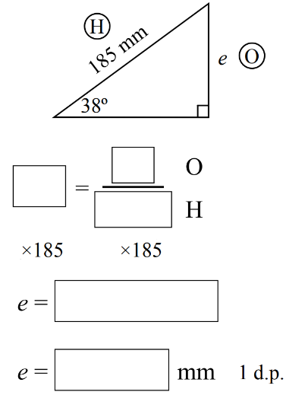  113.9 mm

Development
- Calculate the value of $x$ correct to 2 decimal places using the sine, cosine, or tangent ratios.
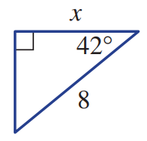  5.95 | 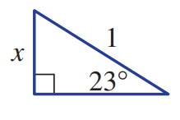  0.39 | 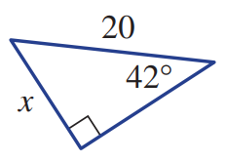  13.38
3.83 | 8.40 | 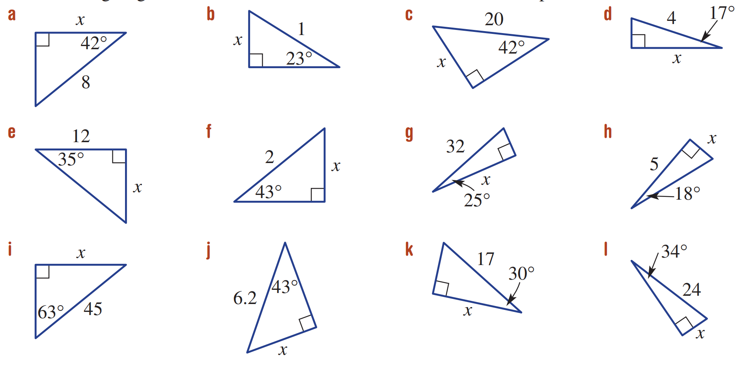  1.36
29.00 | 1.62 | 40.10
4.23 | 14.72 | 13.42

Mastery
- Amy walks 5.4 m up a ramp that is inclined at 12° to the horizontal.
How high (correct to 2 decimal places) is she above her starting point?
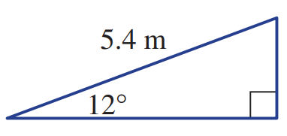

1.12 m
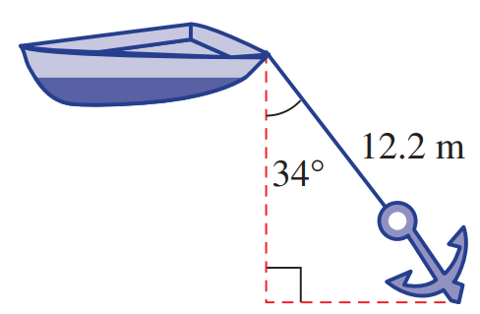
- One end of a 12.2 m rope is tied to a boat. The other end is tied to an anchor, which is holding the boat steady in the water. If the anchor is making an angle of 34° with the vertical,
how deep is the water? Give your answer correct to 2 decimal places.

10.11 m
- Consider the right-angled triangle on the right.
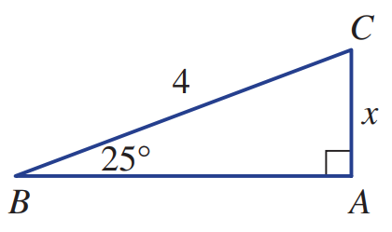
  - Find angle $∠C$

65$°$
- Calculate $x$ using the sine ratio.  1.69 | - Calculate $x$ using the cosine ratio.  1.69

Finding Unknown Sides Part 2

- Review
- To solve an equation with an unknown as the denominator we can first multiply both sides by that unknown. Solve these equations.
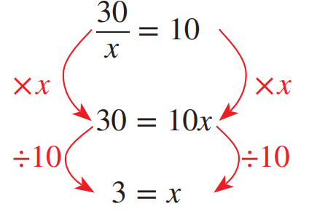 | 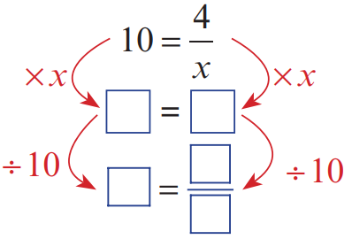 | - $\frac{4}{x}$ $=2$
- $\frac{20}{x}$ $=4$ | - $\frac{15}{x}$ $=5$ | - $2=$ $\frac{12}{x}$

- Example Solve trigonometric equations: unknown in denominator
$$\cos{60°}=\frac{5}{x} \\ ×x=×x \\ x cos{60°}=5 \\ ÷\cos{60°}=÷\cos{60°} \\ x=\frac{5}{\cos{60°}} \\ =10$$

- Guided Practice
Solve these equations. Round your answer to 2 decimal places.
$$\cos{47°=}\frac{26}{x}$$  $$x=38.12$$ | $$\sin{53°}=\frac{26}{x}$$  $$x=32.56$$
$$\tan{44°}=\frac{15}{x}$$  $$x=15.53$$ | $$\cos{49°}=\frac{6}{x}$$  $$x=9.15$$
- Solving for an Unknown Side
- Label sides.
- Determine trig ratio.
- Write trig equation.
- Substitute known values.
- Solve equation.

- Example Calculate an unknown side using trigonometry; unknown in numerator
Calculate the value of $x$ in these right-angled triangles.
1. label  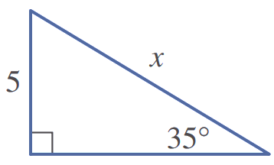  2. sin  Opp  Hyp  3. $\sin{θ}=$ $\frac{O}{H}$  4. $\sin{35°}=$ $\frac{5}{x}$  5. $x\sin{35°}=5$  $x=$ $\frac{5}{\sin{35°}}$  $≈8.72$ | 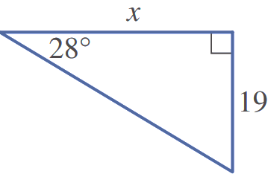  1. label  Opp  Adj  2. tan  3. $\tan{θ}=$ $\frac{O}{A}$  4. $\tan{28°=}$ $\frac{19}{x}$  5. $x\tan{28°}=19$  $x=$ $\frac{19}{\tan{28°}}$  $≈35.73$

- Guided Practice
Calculate the value of $x$ in these right-angled triangles. Round your answer to 2 d.p.
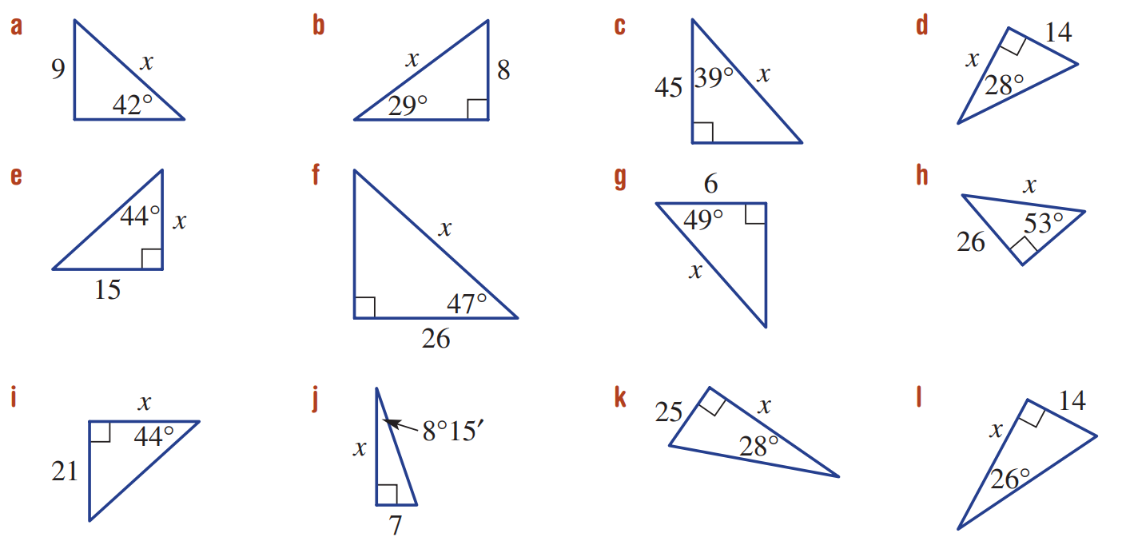  1. Label  2.  3.  4.  5.  $$x=38.12$$ | 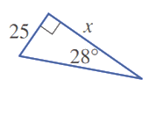  $$x=47.02$$

Foundation
- Solve the equation to find the value of $x$ correct to 2 decimal places.
- $\cos{43°}=$ $\frac{3}{x}$  $x\cos{43°=}3$  $x=$ $\frac{3}{\cos{43°}}$  $=$ ………  4.10 | - $\sin{36°}=$ $\frac{4}{x}$  $x\sin{36°=}4$  $x=\frac{ }{ }$  $=$ ………  6.81 | - $\cos{33}=$ $\frac{6}{x}$  7.15
- Emma noticed a shortcut when solving these equations:
Instead of writing:  $$2=\frac{3}{x} \\ 2x=3 \\ x=\frac{3}{2}$$ | We can skip a step:  $$2=\frac{3}{x}$$  swap  $$x=\frac{3}{2}$$



Solve these equations using the shortcut.
- $\tan{64°}=$ $\frac{2}{x}$  $x=$ $\frac{2}{\tan{64°}}$  $x=$  0.98 | - $\cos{67°}=$ $\frac{5}{x}$  12.80 | - $\sin{12°}=$ $\frac{3}{x}$  14.43
- Find the side length by setting out your working as shown. Round your answer to 1 d.p.
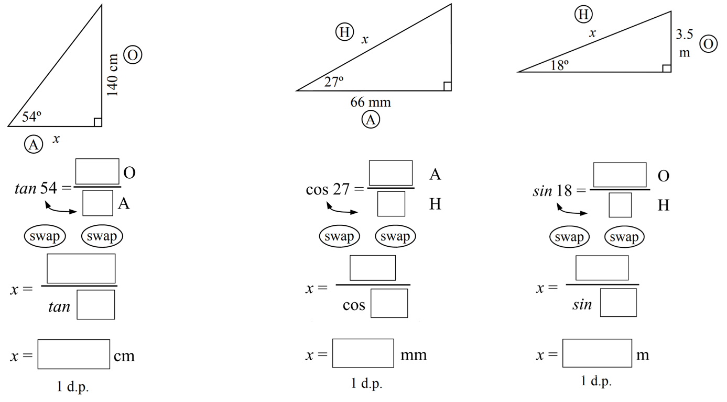  101.7 cm | 74.1 mm | 11.3 m
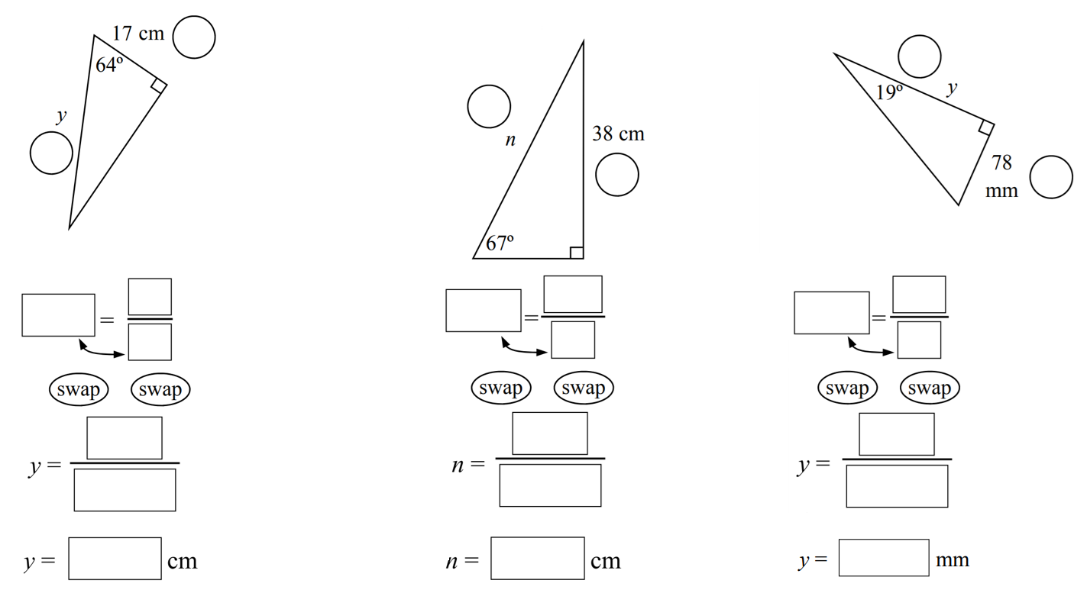  18.9 cm | 41.3 cm | 226.5 mm

Development
- Calculate the value of $x$ correct to 2 decimal places.
13.45 | 16.50 | 57.90
26.33 | 15.53 | 9.15

- Calculate the value of the pronumeral, to 2 decimal places.

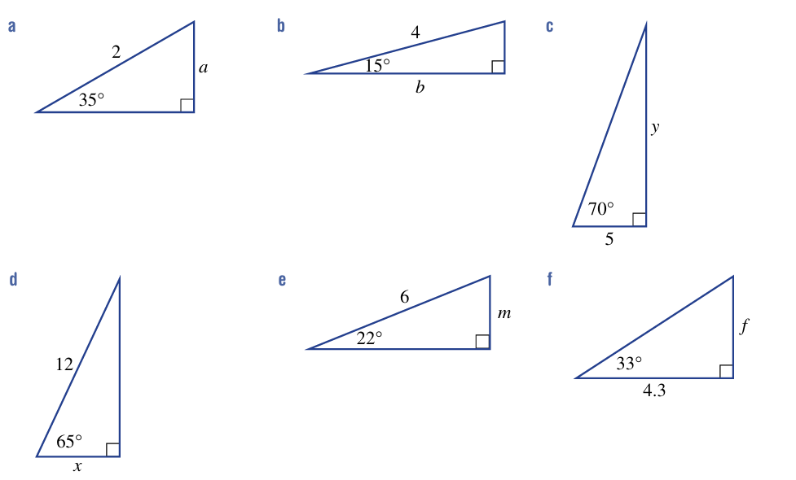  1.15 | 3.86 | 13.74
5.07 | 2.25 | 2.79

Mastery
- Solve for $x$.
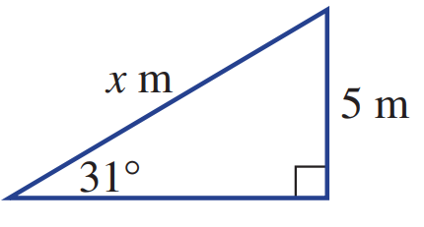

Two students provide different answers in the test. Which student is more accurate?
What mistake have they made?
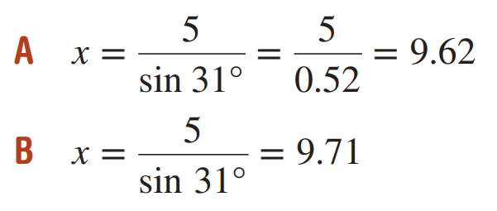

Student B is more accurate. Student A rounded too early.
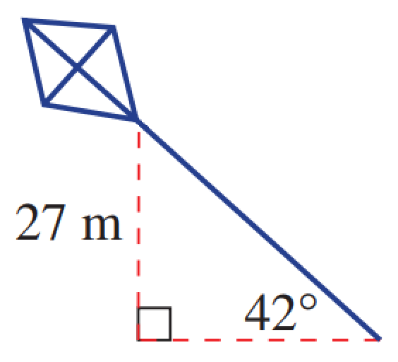
- A kite is flying at a height of 27 m above the anchor point. If the string is inclined at 42° to the horizontal, find the length of the string correct to the nearest metre.

40 m
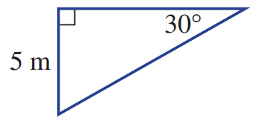
- Find the perimeter of this triangle, correct to 1 d.p.

23.7 m
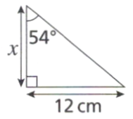
- Find the length of the side labelled $x$.
- by using the 54° angle  $$\tan{54°}=\frac{12}{x}$$  $$x=\frac{12}{\tan{54°}}$$  $=8.72$ cm | - By using the unmarked angle in the triangle.  Missing angle is $180-90-54=36°$  $$\tan{36°}=\frac{x}{12}$$  $$x=12\tan{36°}$$  $=8.72$cm
Which method do you prefer?

- Find the value of each pronumeral correct to 1 decimal place.
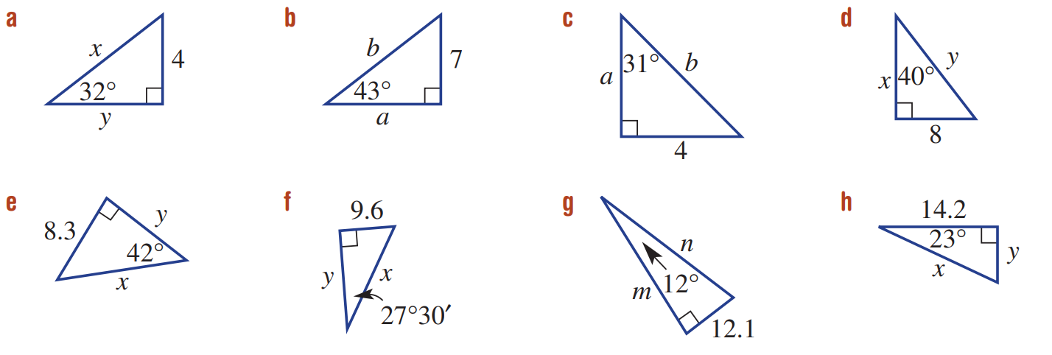  $$x=7.5,y=6.4$$ | 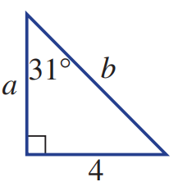  $a=6.7,b=7.8$ | $$x=9.5,y=12.4$$ | $$x=12.4,y=9.2$$

- Find the value of $x$, correct to 1 decimal place, in these triangles.
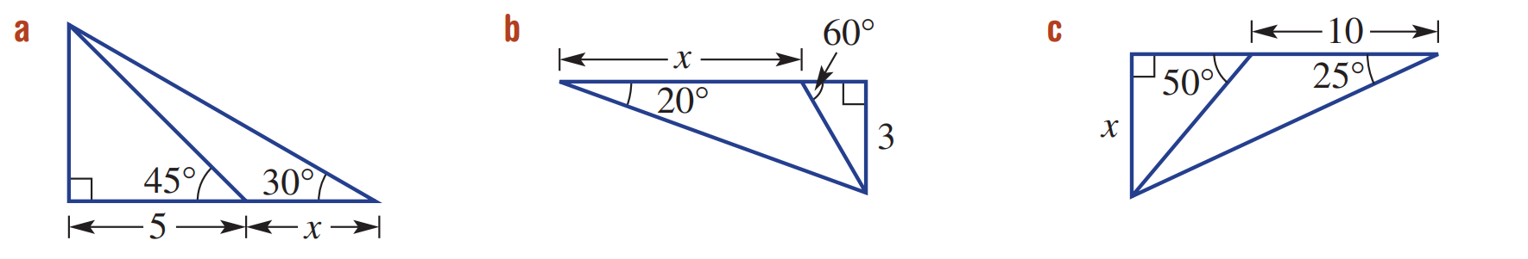  3.7 | 6.5 | 7.7

Finding Unknown Angles

- Review
- Solve these equations.
- $\sin{θ}=0.4$  $θ=\sin^{-1}{( )}$  $=$ | - $\cos{θ}=$ $\frac{4}{5}$ | - $\tan{θ}=32.4$

- Solving for an Unknown Side
- Label sides.
- Determine trig ratio.
- Write trig equation.
- Substitute known values.
- Solve equation.

- Example Calculate an unknown side using trigonometry; unknown in numerator
Calculate the unknown angle in these right-angled triangles.
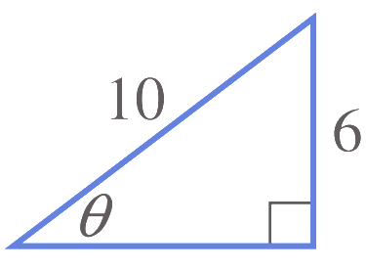  1. Label  Opp  Hyp  2. sin  3. $\sin{θ}=$ $\frac{O}{H}$  4. $\sin{θ}=$ $\frac{6}{10}$  5. $θ=\sin^{-1}\left(\frac{6}{10}\right)$  $θ≈36.87°$ | 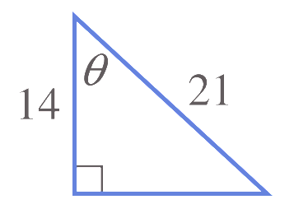  1. Label  Hyp  Adj  2. cos  3. $\cos{θ}=$ $\frac{A}{H}$  4. $\cos{θ}=$ $\frac{14}{21}$  5. $θ=\cos^{-1}\left(\frac{14}{21}\right)$  $θ≈48.19°$

- Guided Practice
Calculate the value of $θ$ in these right-angled triangles. Round your answer to 2 d.p.
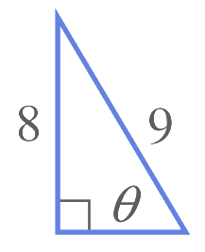  1. Label  2.  3.  4.  5.  $$θ=62.73°$$ | 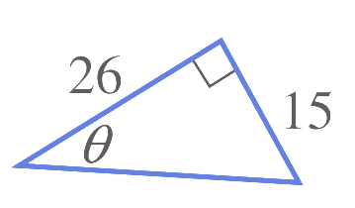  $$θ=29.98°$$

Foundation
- Calculate the value of $θ$ to the nearest degree.
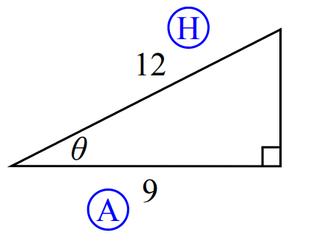  $$\cos{θ}=\frac{9}{12} \\ θ=\cos^{-1}\left(\frac{9}{12}\right) \\ θ=$$  $$41°$$ | 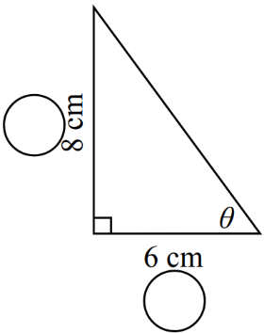  53$°$ | 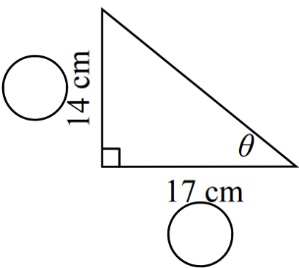  $$39°$$
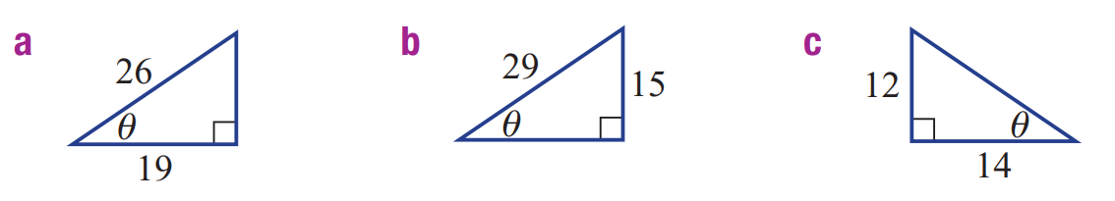  43° | 31° | 41°
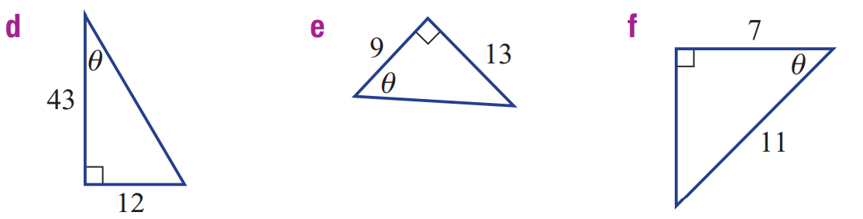  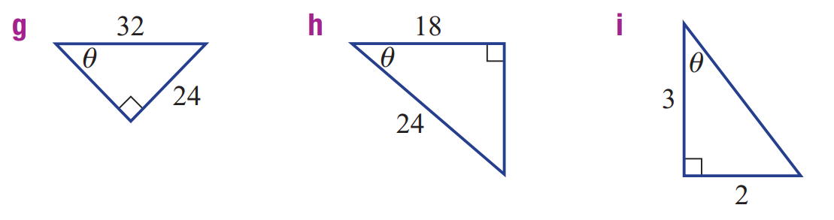  16° | 55° | 50°
49° | 41°

Development
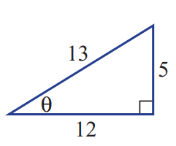
- Refer to the diagram to complete the following, answer to 2 decimal places.

- $\sin{θ}=$    $θ=$  $$22.62°$$ | - $\cos{θ}=$  $θ=$  $$22.62°$$ | - $\tan{θ}=$  $θ=$  $$22.62°$$
What do you notice? Does it make sense?
The answer for all three is $22.62°$. This makes sense as you are finding the same angle in each case.

- Solve for the unknown angle.
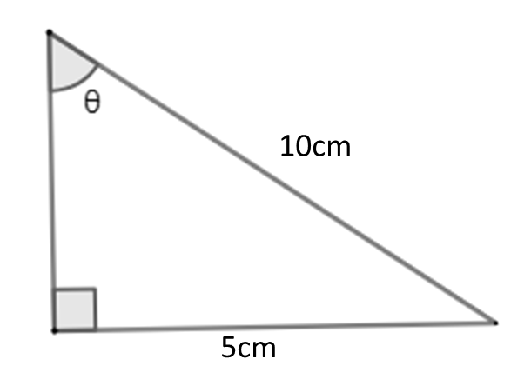  30$°$ | 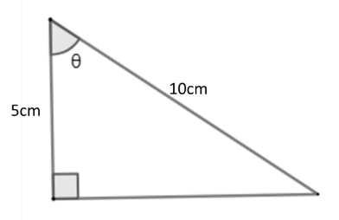  60$°$ | 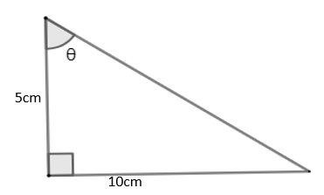  63.4$°$
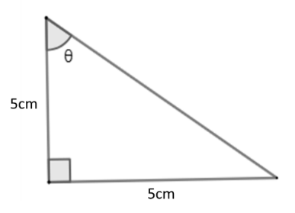  45$°$ | 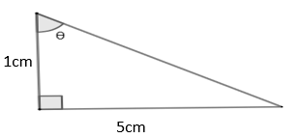  78.7$°$ | 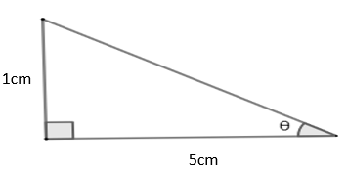  11.3$°$

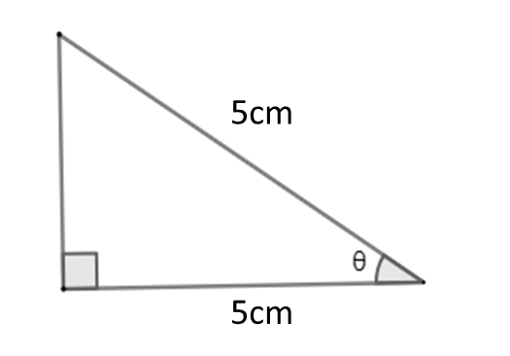
- Solve for $θ$

$$0°$$
Explain why this triangle is impossible.

It’s impossible for a triangle to have an internal angle of zero.
Also, the triangle’s hypotenuse and adjacent are equal, which is impossible as the hypotenuse must be the longest side.

Mastery
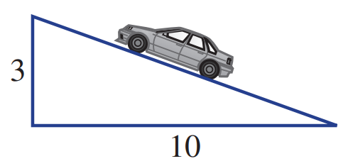
- A road rises at a grade of 3 in 10.
Find the angle (to the nearest degree) the road makes with the horizontal.

17$°$
- Find the value of $x$. Answer to 2 decimal places.
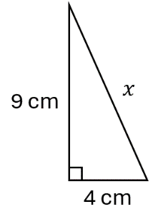  $\sqrt{97}=9.85$ cm | 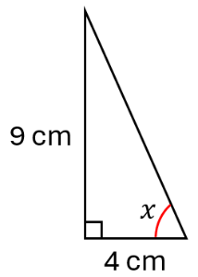  66.04$°$ | 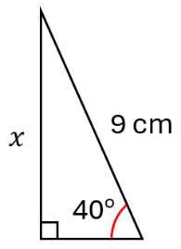  $5.79$ cm
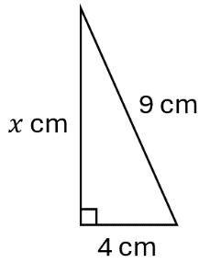  $\sqrt{65}=8.06$ cm | 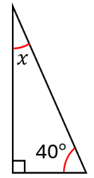  $$50°$$ | 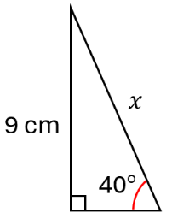  14.00 cm

- Calculate the value of $θ$ in these diagrams. Answer to 1 d.p.
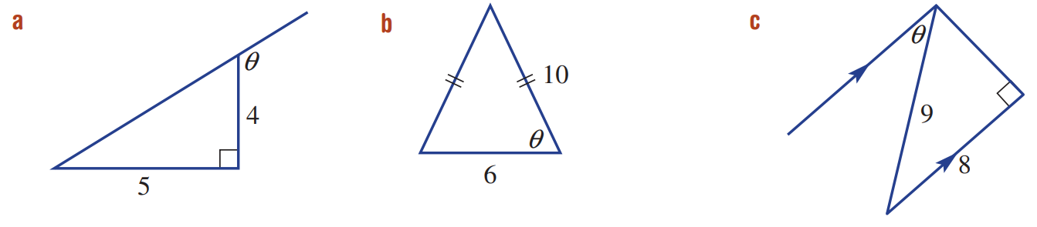  128.7° | 72.5° | 27.3°

- Solve for the unknown side. Answer to 1 d.p.
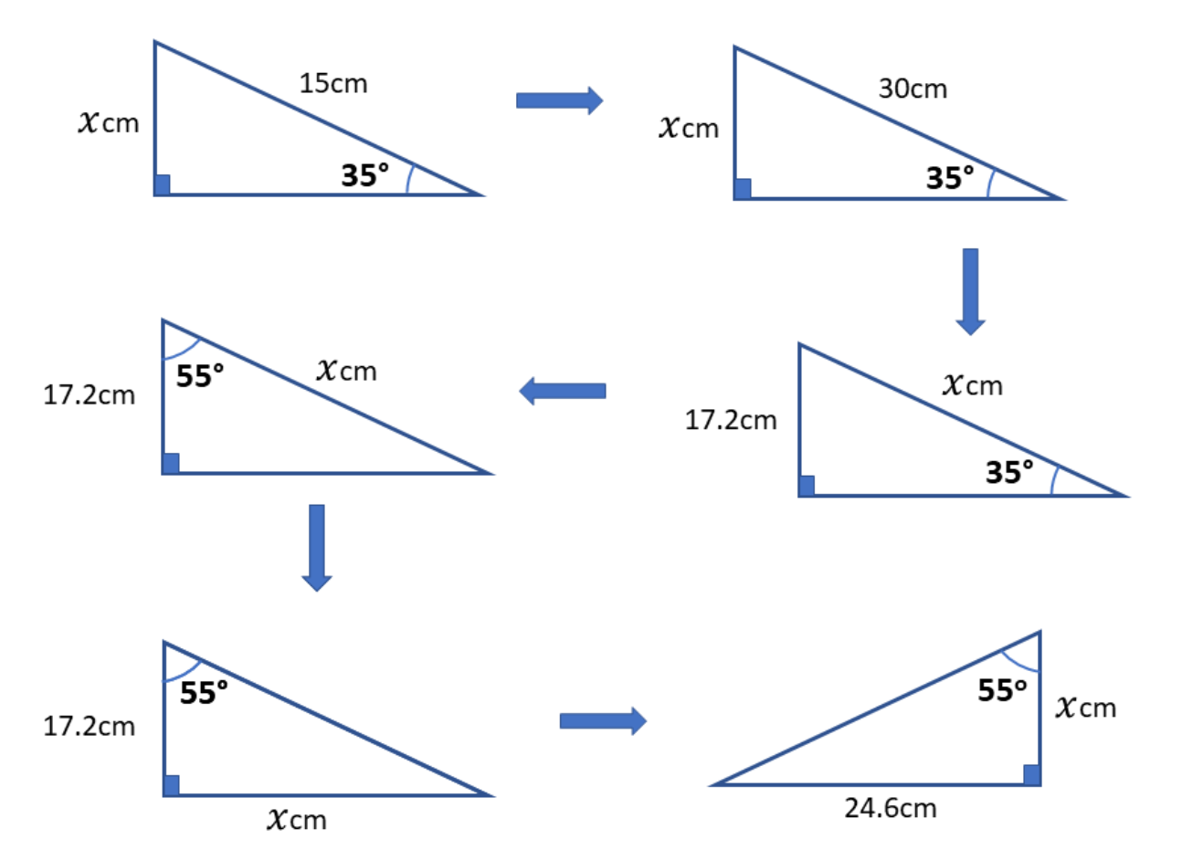  30.0 cm | 24.6 cm | 17.2 cm
17.2 cm | 67.6 cm | 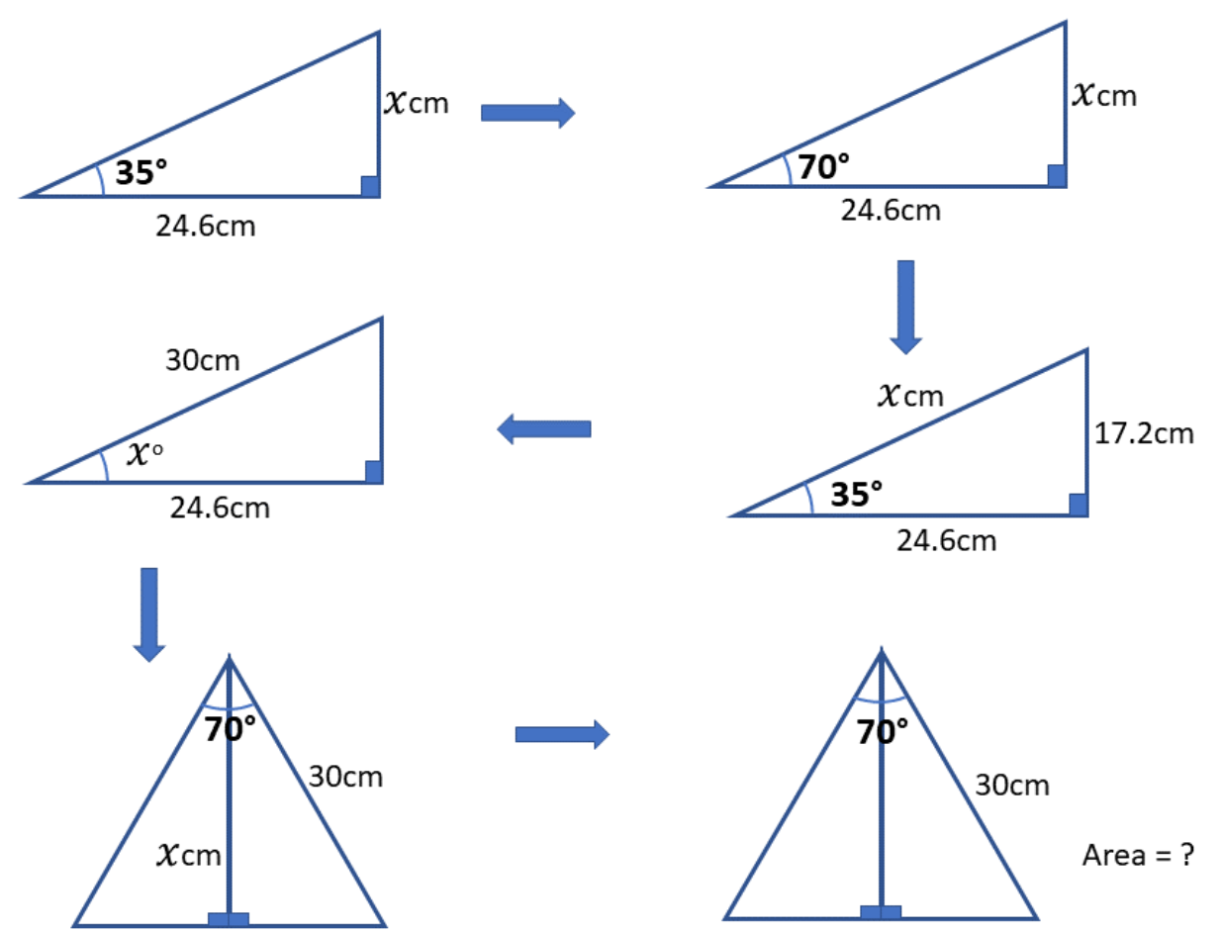  30.0 cm
$$35°$$ | 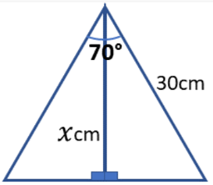  24.6 cm | 422.9 cm²

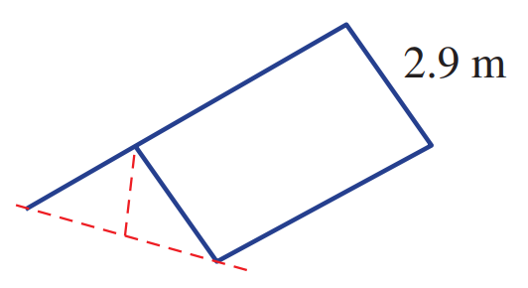
- A tent with a simple A-frame design is set up as a shelter. The breadth of half of the tent is 2.9 metres, as shown. Find the angle to the ground that the sides of the tent make if the height at the middle of the shelter is 1.5 metres. Round your answer to the nearest 0.1 of a degree.

31.1°
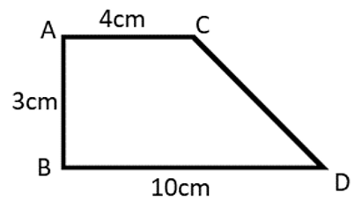
- Consider the following shape; answer all questions to 1 d.p,

- Calculate the area of $ΔBCD$  15 cm² | - Calculate the perimeter of the trapezium.  23.7 cm
- Find the size of $∠CDB$ to 1 d.p.  26.6$°$ | - Find the size of $∠ACD$ to 1 d.p.  153.4$°$
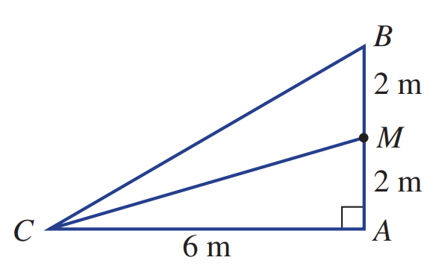
- $M$ is the midpoint of $AB$. Determine whether the angle $∠ACM$ is exactly half of angle $ACB$.

∠ACM = 18.4° ∠ACB = 33.7° , no it is not half

Degrees Minutes Seconds

- Sexagesimal System
- Our number system is called the decimal system based on tens.
  - Ten ones are ten. Ten tens are a hundred. Ten hundreds is a thousand…
- Angles use the sexagesimal system, based on sixties.
  - Sixty seconds are a minute. Sixty minutes are a degree.

Degree $°$ | $$\frac{1}{360} of a turn$$
Minute ′ | $$\frac{1}{60} of a degree$$
Second ′′ | $$\frac{1}{60} of a minute$$
Convert between decimal form and sexagesimal form by using the buttons:


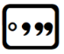
or
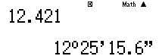

Hours
Minutes
Seconds

- Convert between sexagesimal form and decimal form
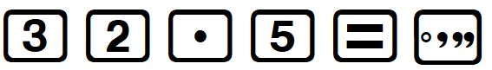  $32.5°$  $=32° 30'$ |  | 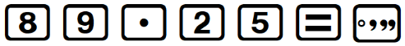  $89.25°$  $=89° 15'$
Convert these angles from decimal form to sexagesimal form
- $44.75°=$  $$44°45'$$ | - $36.6°=$  $36°36'$ |  | - $0.1°=$  $0°6'$
- $77.2°=$  $$77°12'$$ | - $0.5°=$  $$0°30'$$ |  | - $126.1552°=$  $$126° 9^{'} 18.72''$$
- Rounding in Sexagesimal Form
- Draw a “cut” after the required unit.
- Circle the critical unit right after the cut.
- Decide to round up to down.
  - If critical unit is less than 30, round down.
  - If critical unit is 30 or more, round up.
- Round.
  - rounding down: Remove digits after the cut.
  - rounding up: Add 1 to digit before the cut, then remove digits after the cut.

- Example Round to the nearest degree and minute
Round $43° {44}^{'} 8.4''$ to the nearest degree.  1. Draw cut 43 $°$ 44 $'$ 8.4 $''$  2. Critical digit 43 $°$ 44 $'$ 8.4 $''$  3. Decide Round up  4. Round $44°$  $43° {44}^{'} {8.4}^{''}≈44°$ | Round $88° {30}^{'} 22''$ to the nearest minute.  1. Draw cut 88 $°$ 30 $'$ 22 $''$  2. Critical digit 88 $°$ 30 $'$ 22 $''$  3. Decide Round down  4. Round $88°30'$  $88° {30}^{'} {22}^{''}≈88°{30}^{'}$

- Guided Practice
Round these angles to the nearest minute.
- $51° {59}^{'} 8^{''}$  $51°59'$ | - $33° {22}^{'} {47}^{''}$  $33°23'$ | - $41° {24}^{'} {47}^{''}$  $41°25'$
- $42.5825°$  $42°35'$ | - $74.2842°$  $74°17'$ | - $14.5°$  $14°30'$

- Key Ideas
- There are 60 …………… in 1 degree.
- There are 60 …………… in 1 minute.
- When rounding to the nearest degree or minute, we use …………… as the halfway mark.

Foundation
- Complete these sentences:
  - ……… degrees make a full turn, or revolution.

  - 60 …………… make up one degree.

  - 60 …………… make up one minute.

- Convert these angles in decimal form to degrees, minutes, and seconds.
- 25.1° = 25°……′  25° 6' 0" | - 25.2° = 25°……′  25° 12' 0" | - 25.25° = 25°……′  25° 15' 0"
- 25.5° = 25°……′  25° 30' 0" | - 25.625° = 25°……′……′′  25° 37' 30" | - 25.75° = ……………  25° 45' 0"

- Round these angles to the nearest degree.
- 11° 38’  12° | - 55°1 6’  55° | - 49° 46’  50°
- 70° 28’  70° | - 79° 30’  80° | - 18° 27’  18°
- 42° 21’ 44’’  42° | - 44° 35’ 21’  45° | - 29° 21’ 45’’  29°

- Round these angles to the nearest minute.
- 43° 52’ 11.71’’  43° 52’ | - 35° 13’ 24.05’’  35° 13' | - 42° 59’ 28.76’’  42° 59'
- 19° 27’ 11.66’’  19° 27' | - 76° 49’ 23.05’  76° 49' | - 14° 30’ 55.17’’  14° 31'

- Convert these angles in decimal form to sexagesimal form and round to the nearest minute.
- 25.2875°  25° 17' | - 45.16666°  45° 10' | - 67.4916°  67° 29'
- 72.4215°  72° 25' | - 22.3°  22° 18' | - 87.252°  87° 15'

Trigonometry with Sexagesimals

- Trigonometry with Sexagesimals
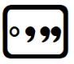
The button is used to insert angles in terms of degrees and minutes into the calculator
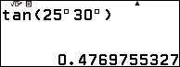
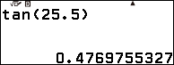

- Example Calculate unknown sides when angle is in sexagesimal form
Calculate the value of $x$. Round your answer to 2 decimal places
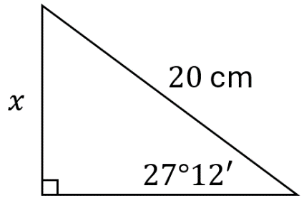  $$\sin{(27°{12}^{'})}=\frac{x}{20} \\ 20\sin{(27°{12}^{'})}=x \\ 9.14 cm=x$$ | 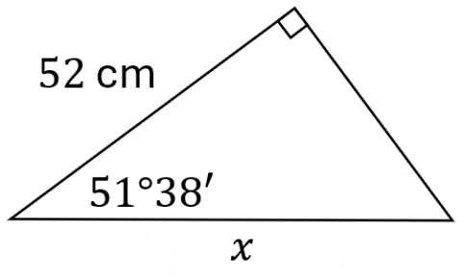  $$\cos{(51°{38}^{'})}=\frac{52}{x} \\ x\cos{(51°{38}^{'})}=52 \\ x=\frac{52}{\cos{(51°{38}^{'})}} \\ =84.78 cm$$

- Guided Practice
Calculate the value of $x$. Round to 2 decimal places.
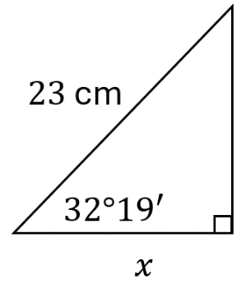  $19.44$ cm | 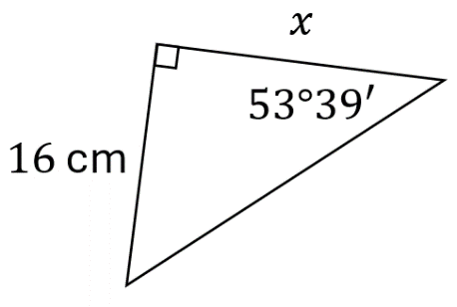  $x=11.77$ cm

- Example Calculate an unknown angle and round the result
Calculate the value of $θ$ and round to the nearest minute.
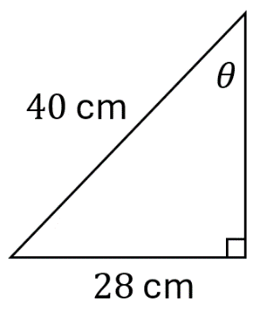
$\sin{θ=\frac{28}{40}}$
$θ=\sin^{-1}\left(\frac{28}{40}\right)$
$θ≈44.4270$
$≈44° {25}^{'}{ 37.21}^{''}$
$≈44° 26'$

- Guided Practice
Calculate the value of $θ$ and round to the nearest minute.
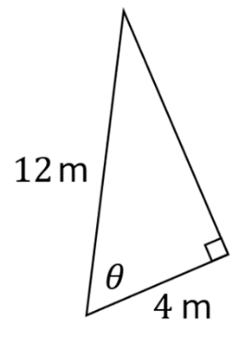  $$θ=70°32'$$ | 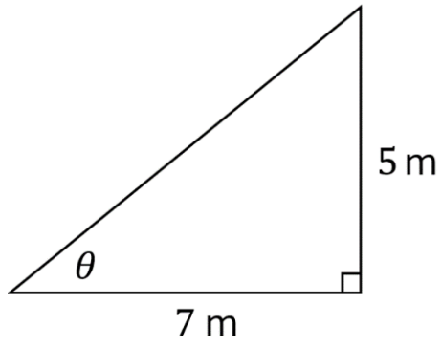  $$θ=35°32'$$

Foundation
- Evaluate these trigonometric ratios using the DMS button on the calculator. Answer to 4 d.p.
- cos 89°21′  0.0113 | - tan 18°23′  0.3323 | - tan 68°23′  2.5236
- 8.3 tan 58°51′  13.7320 | - 15 sin 48.18°  11.1786 | - 12.3 cos 27°48′  10.8803

- Calculate the value of the unknown side in each of the following. Answer to 2 d.p.
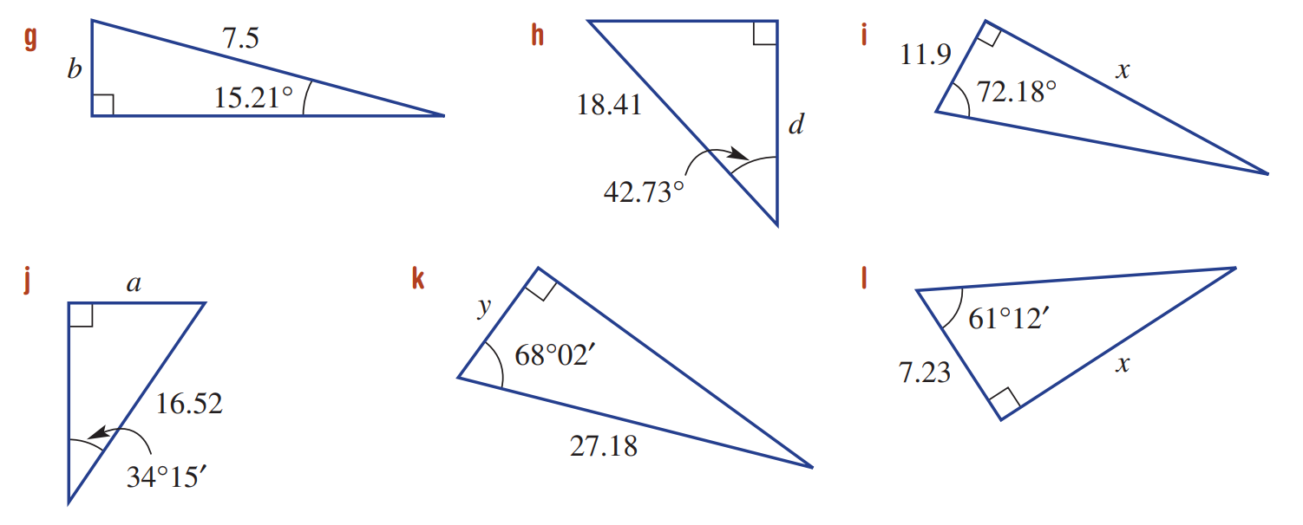  1.97 | 13.52 | 37.02
9.30 | 10.17 | 13.15

- Calculate $θ$ in each of the following, round to the nearest minute.
- sin⁻¹ (0.7324)  47° 5' | - cos⁻¹ (0.9763)  12° 30' | - tan⁻¹ (0.3321)  18° 22'
- tan⁻¹ (1.235)  51° 0' | - sin⁻¹ (0.4126)  24° 22' | - cos⁻¹ (0.7462)  41° 44'
- sin θ = 0.5  30° 0' | - tan θ = 0.5774  30° 0' | - tan θ = 1.192  50° 0'
- sin θ = $\frac{4}{7}$  34° 51' | - cos θ = $\frac{4}{5}$  36° 52' | - tan θ = $\frac{8}{5}$  58° 0'

Development
- Calculate the value of $θ$ in each of the following, round to the nearest minute.
$$48°35'$$ | $$52°7'$$ | 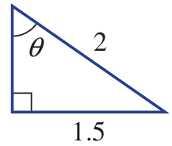  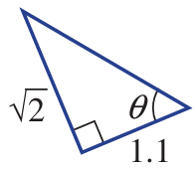  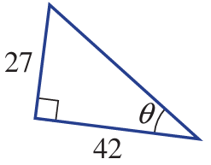  $$32°44'$$

- Calculate the value of the unknown value, to 2 d.p. for lengths and nearest minute for angles.
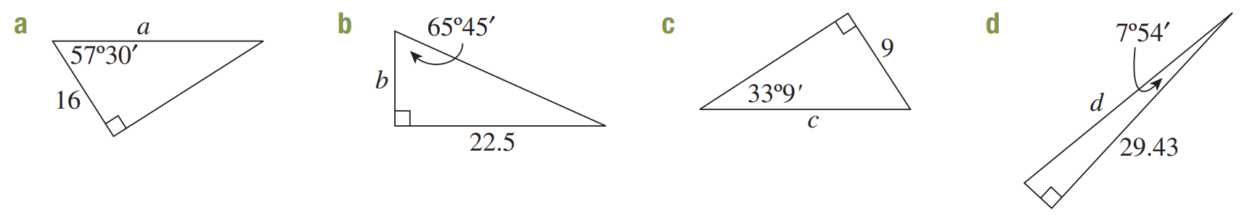  29.78 | 10.14 | 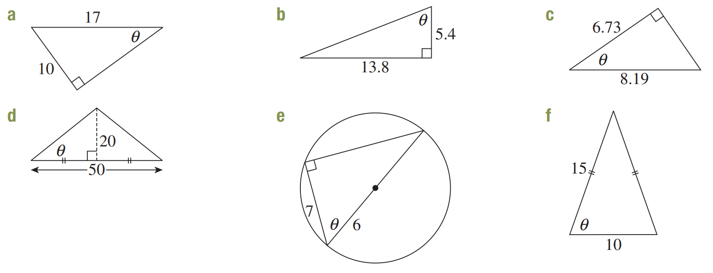  36°2′
29.71 | 68°38′ | 34°44′

- Find the values of the pronumerals, to 2 d.p. for lengths and nearest minute for angles.
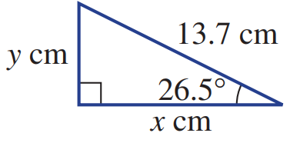  x = 12.26 cm, y = 6.11 cm | 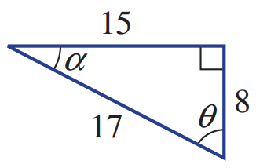  α = 28°4’ , θ = 61°56’

Problem-solving using Trigonometry

- Problem-solving using Trigonometry
- Identify the right-angled triangle.
- Label the unknown side or angle $x$ or $θ$, if it isn’t already.
- Solve for the unknown using trigonometry.

- Example Solve practical problems involving trigonometry
Find how high the ladder reaches up the wall.  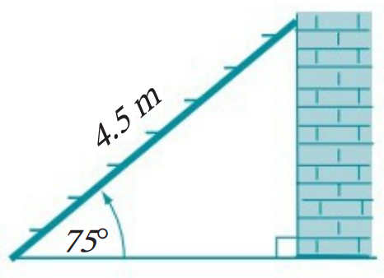  $$h$$  1. Triangle  2. Unknown $\left(h\right)$  3. Solve  $\sin{75°=}$ $\frac{h}{4.5}$  $4.5\sin{75°=h}$  $x≈4.35$ m | 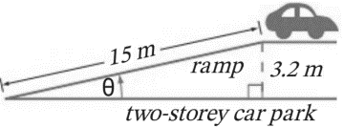  Find the angle of the ramp.  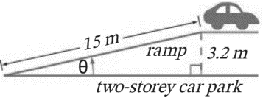  1. Triangle  2. Unknown $\left(θ\right)$  3. Solve  $\sin{θ}=$ $\frac{3.2}{15}$  $θ=\sin^{-1}\left(\frac{3.2}{15}\right)$  $θ≈12.32°$

- Guided Practice
- Determine the height of this tree.  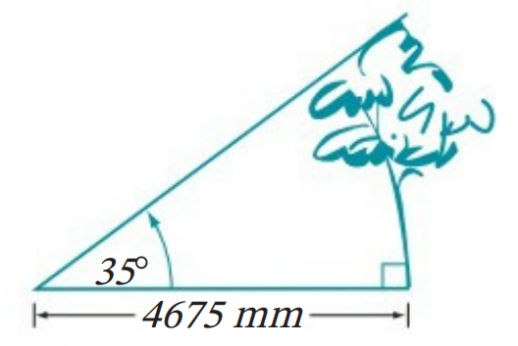  $x=3273.47$ mm | - Find the angle between the kite and the ground.  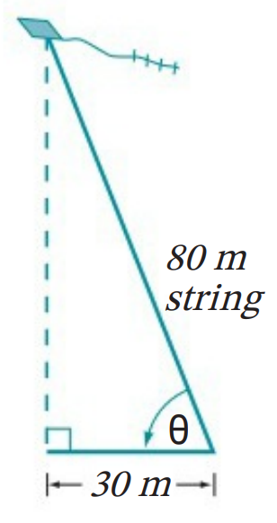  $$θ=67.98°$$

Foundation
- For each question, solve for the unknown value.
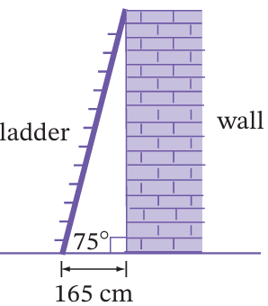
  - Calculate the length of the ladder to the nearest cm.

638 cm
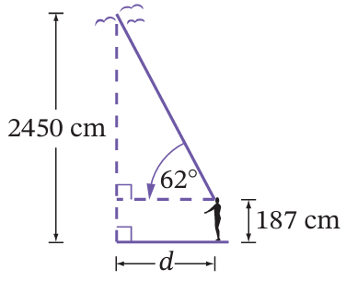
  - Calculate the horizontal distance of the person from the birds, to 1 d.p.

1203.3 cm
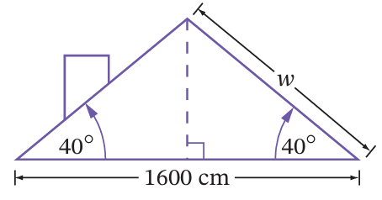
  - The slant height of the roof, to 1 d.p.

1044.3 cm
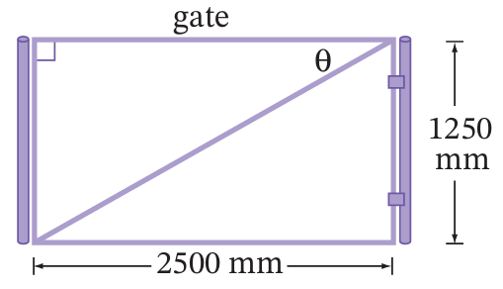
  - The angle of the gate diagonal, to the nearest minute.

$$26°34'$$
  - The angle of the leaning water tower, to the nearest minute.
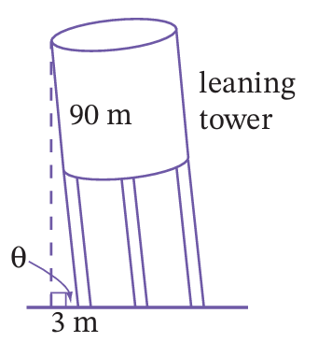

$$88°5'$$
- A garage has a roof shown in the diagram.
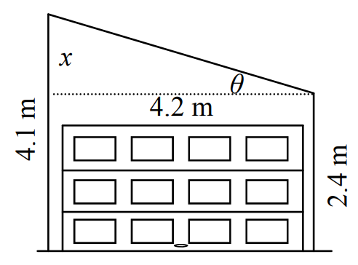
  - Calculate the height difference between the two walls.

1.7 m
  - Find the angle of the roof to the nearest minute.

$$22°2'$$
- Toby constructed two isosceles right triangles.
He says that when the two short sides are the same the angle $θ$ is always $45°$.
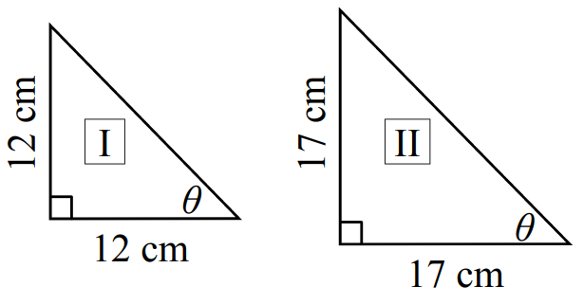
  - Show he is correct, using trigonometry
in the two triangles.

$$\tan^{1}\left(\frac{12}{12}\right)=45°, \tan^{-1}\left(\frac{17}{17}\right)=45°$$
  - Show he is correct, using properties of isosceles triangles and angle sum of a triangle.
$$θ+θ+90°=180°$$
$$2θ=90°$$
$$θ=45°$$
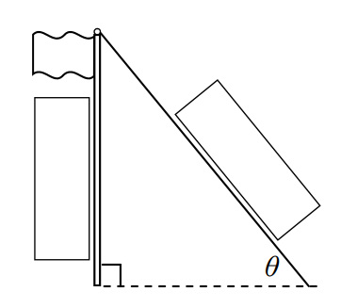
- A 4.5 m flagpole has a 5.6 m wire anchored into the ground.
Calculate the angle that the wire makes with the ground to the nearest minute.

$$53°28'$$
- A triangle skateboard ramp is 3.5 m long and 80 cm high.
Calculate the angle that it makes with the ground to the nearest minute.
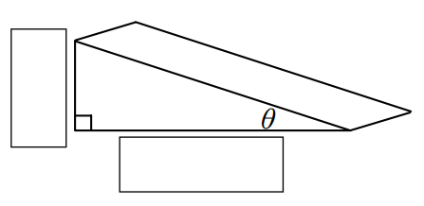

$$12° 5'$$

Development
- A fishing boat is anchored in 65 m deep water. The anchor rope is 90 m long.
Calculate the angle the rope makes with the sea floor, to the nearest minute.
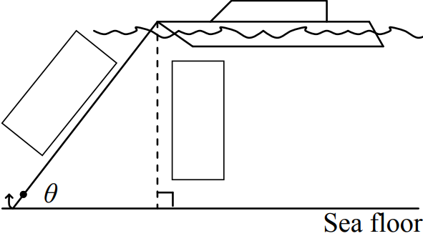

$$46°14'$$
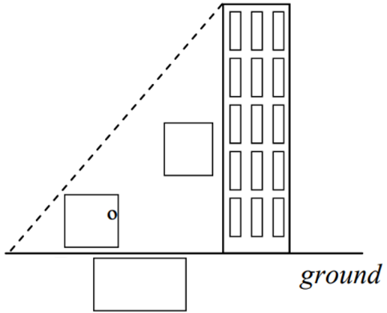
- Jess looks up at a building that is 72 m away. She looks up at an angle of 54$°$.
Complete the diagram then calculate the height of the building to 1 d.p.

99.1 m
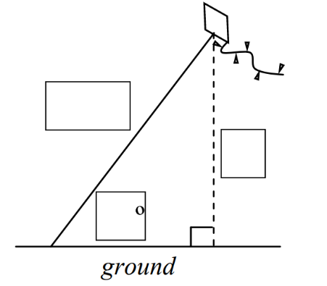
- A kite string is 55 m long and is fully extended.
The string makes an angle of $64°$ with the ground.
Calculate how high above the ground it is to 1 d.p.

49.4 m
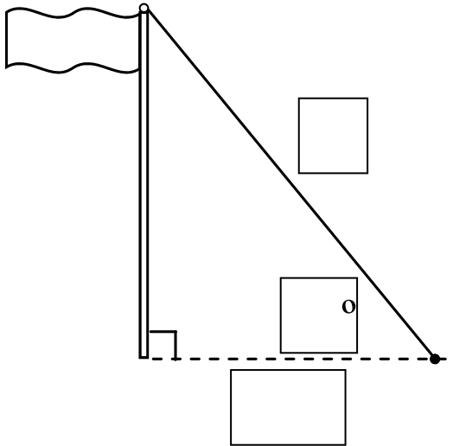
- A flagpole has a wire that secures it to the ground 6 m from the pole.
The wire makes an angle of $51°$ with the ground.
Calculate the length of the wire.

9.5 m
- For the following questions, you will need to draw your own diagrams.
  - A ladder rests against a wall. The foot of the ladder is 355 cm from the wall and makes an angle of $63°20'$ with the ground.
Calculate the length of the ladder to the nearest cm.

791 cm
  - A glider is flying at an altitude (height) of 1.5 km.
To land, it descends at an angle of $18°$ to the ground.
How far must the glider travel before landing? Answer rounded to the nearest 0.1 km.

4.9 km
  - The entrance to the school is 60 cm above ground level.
A wheelchair ramp is to be built at an angle of $4°$ to the ground.
How far from the library must the ramp start? Answer to the nearest cm.

858 cm
  - An aircraft is at an altitude of 770 m. It is 1.5 km horizontally from the airport.
What angle must it descend by to land safely? Answer to the nearest minute.

$$27°10'$$
  - A cannon on level ground shoots at a target, but the cannonball misses by 25 m.
If the target is 1 km away, what angle do they need to adjust the cannon?
Answer to the nearest minute.

$$1°26'$$

Mastery
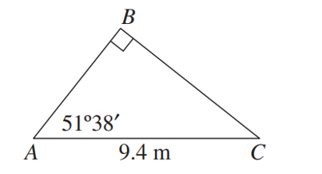
- A tree snapped into two sections $AB$ and $BC$ in high winds and then fell. The section $BA$ is inclined at $51°38'$ to the horizontal and $AC$ is 9.4 metres long. Find the height of the original tree, in metres correct to one decimal place.

13.2 m

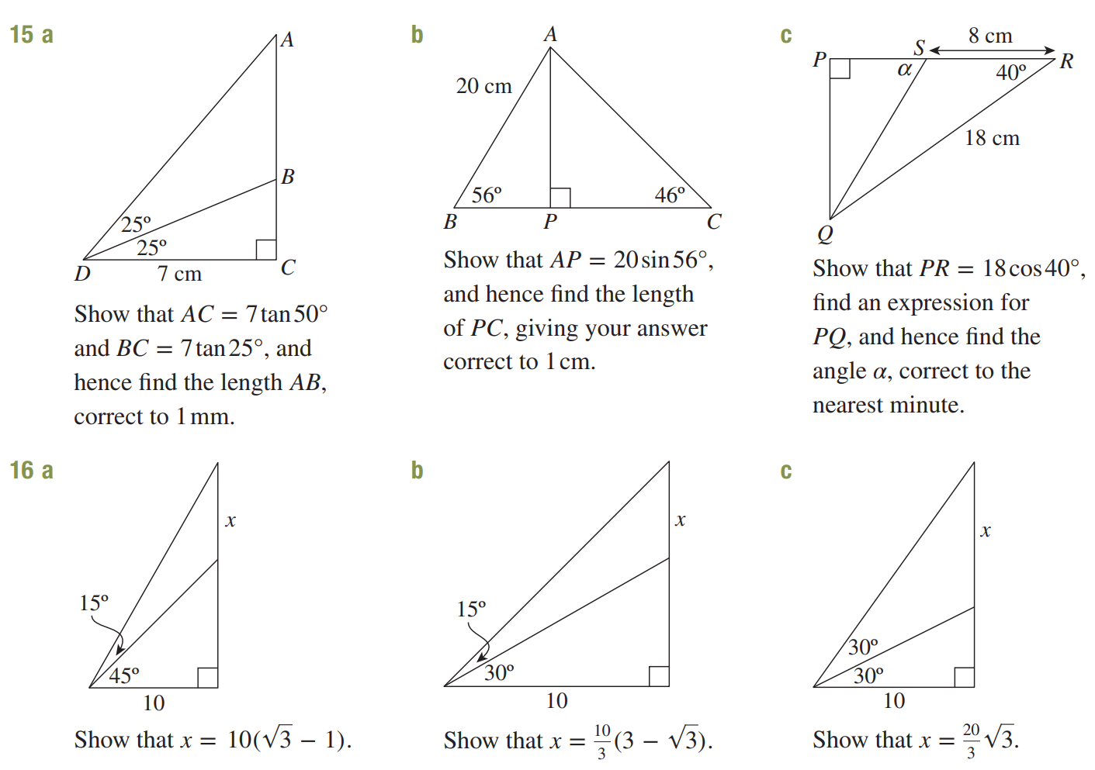  51 mm | 16 cm | $$63°25'$$

- 2019 HSC Standard 2 Band 4
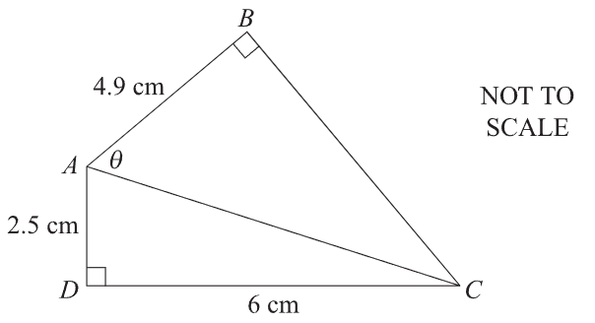
Calculate the size of $θ$. Answer to the nearest minute.

$$41°5'$$
- Find the length $AB$ in these diagrams. Answer to 2 d.p.
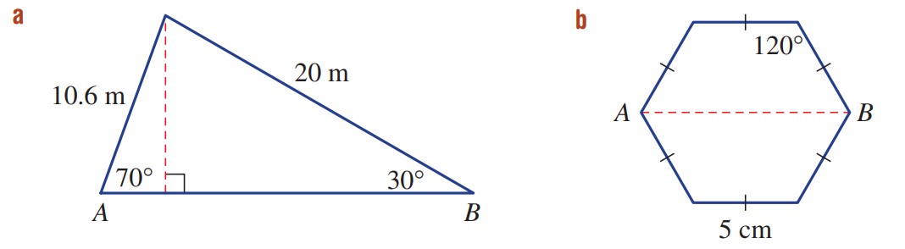  20.95 m | 10 cm
- Find the length $XY$ in these diagrams. Answer to 1 d.p.
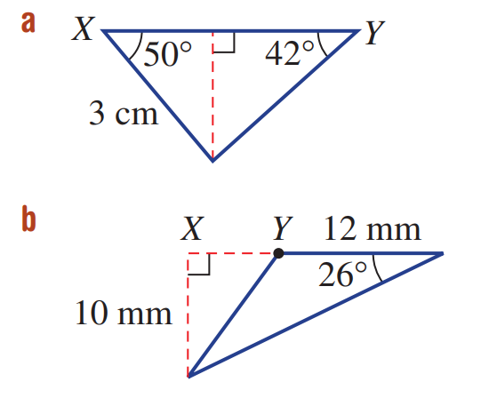  4.5 cm | 8.5 mm
- Find the perimeter of this triangle.
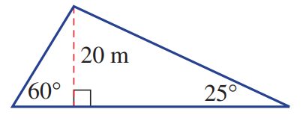

124.86 m
- Find the angle $θ$ in these diagrams. Answer to the nearest minute.
66°25’ | 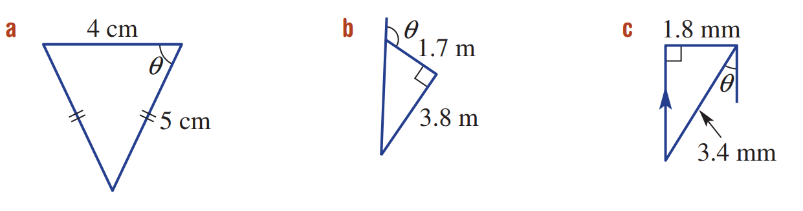  114°6’ | 31°58’
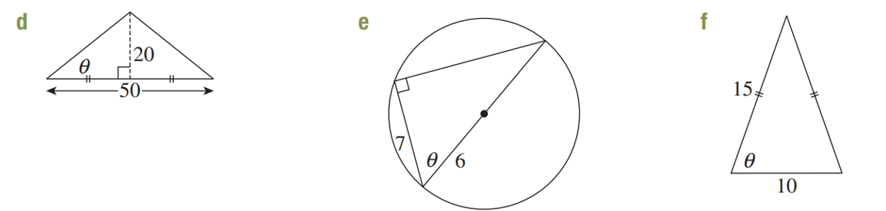  38°40′ | 54°19′ | 70°32′
- It is given that $θ$ is an acute angle and that $\tan{θ}=$ $\frac{\sqrt{5}}{2}$
- Draw a right-angled triangle to show this information. | - Use Pythagoras’ theorem to find the length of the unknown side.  $$\sqrt{9}$$
- Hence write the exact values of $\sin{θ}$and $\cos{θ}$  $$\sin{θ}=\frac{\sqrt{5}}{\sqrt{9}},\cos{θ}=\frac{2}{\sqrt{9}}$$ | - Show that $\sin^{2}{θ}+\cos^{2}{θ}=1$.  $${\left(\frac{\sqrt{5}}{\sqrt{9}}\right)}^{2}+{\left(\frac{2}{\sqrt{9}}\right)}^{2}=\frac{5}{9}+\frac{4}{9}=1$$
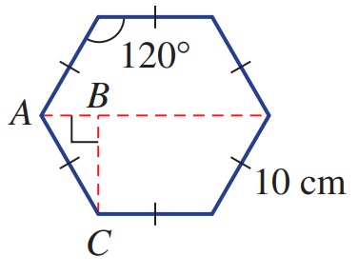
- Consider a regular hexagon with internal angles of 120° and side lengths of 10 cm.
  - Find the length of $BC$ to 2 decimal places.

$$∠BAC=60°$$
$$\sin{60°}=\frac{BC}{10}$$
$BC=10\sin{60°}=$ 8.66 cm
  - Find the length of $AB$.

$$\cos{60°}=\frac{AB}{10}$$
$AB=10\cos{60°}=$ 5 cm
  - Find the distance between the parallel sides to 1 decimal place.

$2BC=20\sin{60°}=$ 17.3 cm
  - Find the distance between two opposite vertices.

$5+10+5=$ 20 cm

- A bridge spans a river, and the two identical sections of the bridge, each of length $x$ metres, can be raised to allow tall boats to pass. When the two sections are fully raised, they are each inclined at 50° to the horizontal, and there is an 18-metre gap between them, as shown in the diagram. Calculate the width of the river in metres, correct to one decimal place.
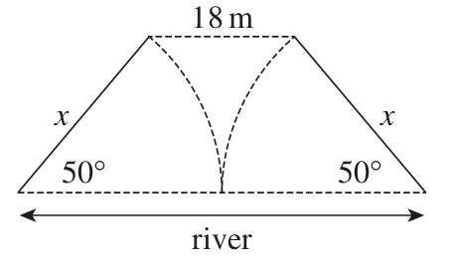

The river is $2x$ m long.
Consider the horizontal projections of the raised bridges: $2x-2x\cos{50°}=18$
$$2x=50.4$$
$∴$ The river is 50.4 metres long.

- Consider the diagram.
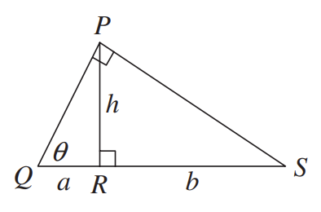
  - Explain why $∠RPS=θ$

∠QPR = 90° − θ, so ∠RPS = θ
  - Find two expressions for $\tan{θ}$

$$\frac{h}{a} and \frac{b}{h}$$
  - Hence show $ab=h^{2}$

$$\frac{h}{a}=\frac{b}{h}, ∴h^{2}=ab$$

- From the ends of a straight horizontal road 1 km long, a balloon directly above the road is observed to have angles of elevation of 57° and 33° respectively.
Find, correct to the nearest metre, the height of the balloon above the road.
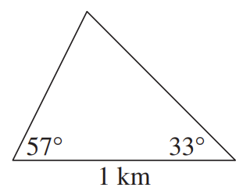
(Hint: create two right-angled triangles by drawing a vertical line)
Draw a vertical line from the apex of the triangle to the base, this represents the height $h$.
This vertical line splits the base into two sections, which we will label $a$ and $b$.
$$\tan{57°}=\frac{h}{a}, \tan{33°}=\frac{h}{b}$$
$$a=\frac{h}{\tan{57°}}, b=\frac{h}{\tan{33°}}$$
$$a+b=1 km$$
$$\frac{h}{\tan{57°}}+\frac{h}{\tan{33°}}=1$$
$$h\left(\frac{1}{\tan{57°}}+\frac{1}{\tan{33°}}\right)=1$$
$$h=\frac{1}{\left(\frac{1}{\tan{57°}}+\frac{1}{\tan{33°}}\right)}=0.45677…$$
$∴$ 457 metres

